|  |
| --- |
| THE HUB |
| A Crowd Sourced Knowledge Transfer & Retention Initiative Hub Steering Committee | 2014 NAYGN Innovation Competition Winner |

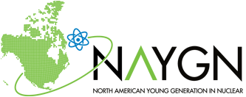



Nuclear Strategic Issues Advisory Committee   
December 11, 2015

Executive Summary

The Nuclear Industry is experiencing a dynamic shift in the age and experience of its work force; resulting in an influx of new and less experienced talent, who are required to be trained and proficient in a short amount of time due to attrition and retirement. The Hub was introduced as an industry-wide knowledge transfer platform that would provide video tutorials, message forums, interactive OE, and image galleries to fill the knowledge, skill and experience gap of newer employees. The Hub would become a repository and exchange for knowledge applicable to the Nuclear Industry. To establish this platform, a Steering Committee was developed to guide and direct the creation and implementation of this initiative. The goal for the Steering Committee was to evaluate different KT&R software platforms and establish a plan for a pilot program.

The Steering Committee evaluated various software options for the Hub platform. These options were consolidated into three finalists: PBWorks, Confluence, and Telligent Community. Out of these finalists, Atlassian’s Confluence was selected by the Steering Committee as the software platform for the Hub. Confluence provided a collaborative workspace environment that facilitates user discussion, knowledge capture and transfer, and the ability to aggregate information from multiple streams. Features that influenced the Steering Committee’s selection were Confluence’s streamlined content feeds, the ability to add media using Drag-and-Drop, pinpoint commenting on images and pages, extensive Confluence software training tutorials, and scalability.

The pilot program, a year-long proof of concept initiative, will be developed using a targeted population of 50 users. Participants will help generate content and provide feedback to the Steering Committee to gauge improvement opportunities and viability for the long term. The pilot program will have periodic monitoring, monthly check-ins and quarterly report outs to Hub stakeholders. The cost of the pilot program will be $3,800, which includes the monthly subscription for Confluence (50 users) and a $200 subscription to VimeoPro for media editing. Long term projections for the Hub used the Nuclear Community as a benchmark, reaching 2,000 users in a four year period. The cost for 2,000 users will be on the order of $20,000 per year; however, it should be noted that users are defined by unique logon credentials with editing rights. Site generic logons or read only options would not necessarily count against the number of cloud users and may minimize overall costs.

The value of the Hub will depend greatly on the content it contains and the exchange of information that occurs between nuclear professionals. There are many implicit benefits that underlie the idea of the Hub: a crowd sourced knowledge base, accessibility to a larger pool of people/SMEs, a unified platform to facilitate exchange of information, and a source of supplemental of learning.

Background

The Nuclear Industry is experiencing a dynamic shift in the age and experience of its work force; resulting in an influx of new and less experienced talent, who are required to be trained and proficient in a short amount of time due to attrition and retirement. This issue is looming over various sectors of the industry: Engineering, Maintenance, Operations, and Training; the figure below is representative of the issue the industry is facing - a wider gap between experienced and inexperienced workers.

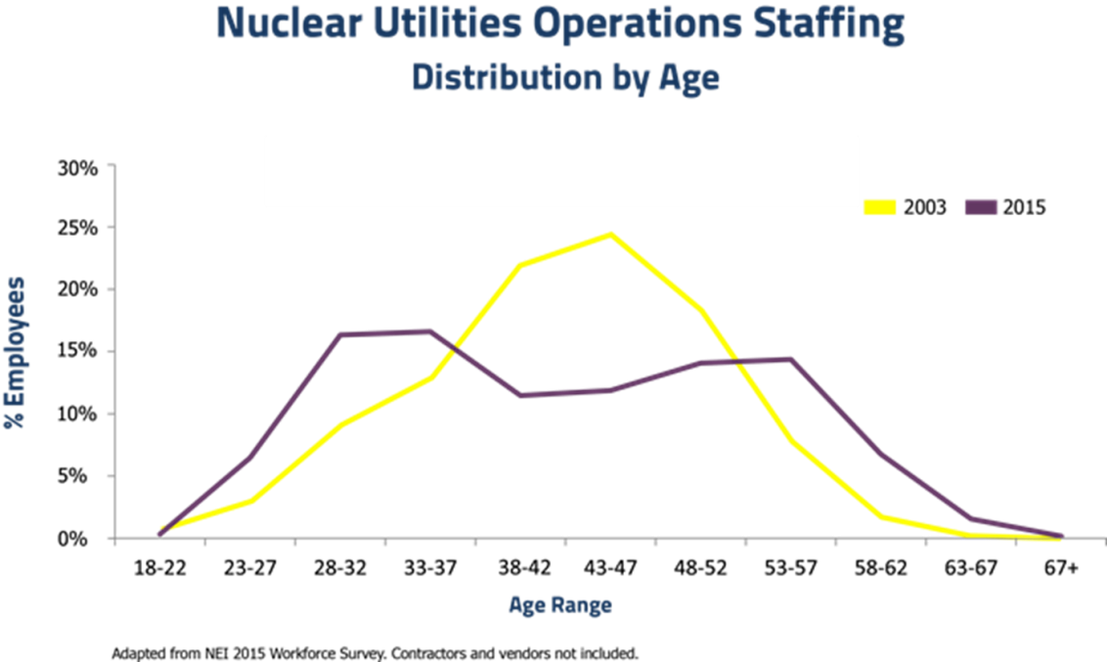

To address this issue, companies and utilities in the Nuclear Industry have undertaken some initiatives to address the potential knowledge gap that is coming in the next 5 to 10 years. Some of these Knowledge Transfer and Retention (KT&R) initiatives have included mentoring programs, knowledge capture databases, and discussion forums with Subject Matter Experts (SMEs). Most of these initiatives were spear headed at site or utility level; however, much of these methods were fragmented due to engagement, availability of resources, and availability of information. A different approach was needed to help make KT&R more effective and provide the means to engage a larger group of people and pool a wider base of knowledge and information. That is where the “Hub” comes into play; the idea of the Hub was proposed at the 2014 NAYGN Innovation Competition.

The Hub was introduced as an industry-wide knowledge transfer platform that would provide video tutorials, message forums, interactive OE, and image galleries to fill the knowledge, skill and experience gap of newer employees. The Hub would become a repository and exchange for knowledge applicable to the Nuclear Industry. The knowledge base would be developed by using a crowd sourced approach, allowing users from all across the industry to generate content and post it to the Hub platform. To establish this platform, a Steering Committee was developed to guide the creation and implementation of this initiative. The goal for the Steering Committee was to evaluate different KT&R software platforms and establish a plan for a pilot program. The pilot program would help evaluate the potential for scalability, sustainability, and improvement opportunities. Additionally, it would help all of the stake holders, NSIAC, NAYGN, and the Steering Committee gauge the viability of a full scale program.

KT&R Platforms

The Steering Committee evaluated various software options for the Hub platform, and these options were consolidated into three finalists: PBWorks, Confluence, and Telligent Community. Each of these options met the base set of requirements for storing and sharing information, member to member communication, and search engine capability. They also provided unique capabilities for users to aggregate and share knowledge through Wikis, discussion forums, and media libraries.

PBWorks

PBWorks is a suite of collaborative tools that has been widely used by organizations in the advertising, legal, and education markets. Some of their notable customers include ESPN, Landor Associates – a global brand consultant, CMS Legal – an international law firm, and TEDx – a grass roots organization that spreads innovative ideas. Key features provided by PBWorks’ Wiki Hub product are content dashboards, mobile accessibility, and document collaboration.

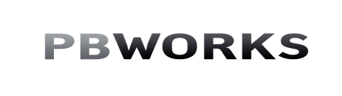

Confluence

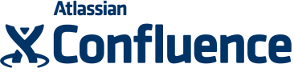Atlassian’s Confluence is a collaborative workspace environment that facilitates team discussion, knowledge capture and transfer, and aggregates information from multiple streams. Some of their notable customers include Facebook, Skype, Netflix, and LinkedIn. Key features provided by Confluence are streamlined content feeds, the ability to add media using Drag-and-Drop, pinpoint commenting on images and pages, extensive Confluence software training tutorials, and scalability.

Telligent (Nuclear) Community

C:\Users\chavgx\Pictures\INPO-NC-LOGO-35-X-122_jpg-250x88.jpgTelligent Community is a social software product that includes a suite of social applications (forums, wikis, blogs, etc.) and social services (likes, ratings, reviews, comments) that are used to create communities of interest for private member communities, internal employee networks, and is the platform used for the INPO-hosted Nuclear Community forum. Key features include *following* members, tagging, and in-application chat feature.

Each platform was an adequate solution for the Steering Committee; however, only one option would be selected for developing the pilot program. Selection would be based on various criteria, the Steering Committee focused on the functionality and ease of use of the software.

Selection Criteria

To aid the Steering Committee in the selection of the software, a feature matrix was developed to evaluate key aspects of the software. The software was evaluated on the following criteria:

* + Member-to-Member Contact (email, messaging, etc.)
  + Threaded Discussions (question & answers, posts & comments, user ratings)
  + Search Engine (comprehensive, indexing, etc.)
  + Document Libraries (Wikis)
  + Ease of Use
  + Video Libraries
  + File Sharing
  + Image Libraries
  + Security (user, content, etc.)
  + Tiered Accounts / Administrative Controls
  + Cost / Funding Requirements
  + Versatility for Future Updates (including scaling)

Selection

To establish the Hub platform the Steering Committee selected Atlassian’s Confluence to help establish an initial pilot program. It will be similar to social media sites like LinkedIn, Youtube, and Instagram, in that they will allow users to create and share content, interact with one another, and foster a sense of community. Confluence offered a variety of capabilities:

* + HipChat – a messenger application with mobile capabilities
  + Questions – a Confluence add on with user rating system for threaded discussions
  + Spaces – a Wiki-like method of organizing content
  + Content and feed bookmarking; including update notifications
  + Tiered user accounts with Read Only anonymous logon capability

Additionally, Confluence’s User Interface was easy to use and its Dashboard provided a clean and organized layout of information. The Functional Areas or *Spaces* provided consolidated streams of related content and the news feeds were tabbed to provide quick access to user relevant content. Members can readily view notifications for new and recently updated content. The top menu bar provides users with the ability to access different content *Spaces*, view member profiles in *People*, ask *Questions*, create new content, search for content, view notifications, and access user *Personal Spaces*. With all of the functionality and ability to scale quickly and seamlessly, Confluence distinguished itself as the best option to use for the pilot program.

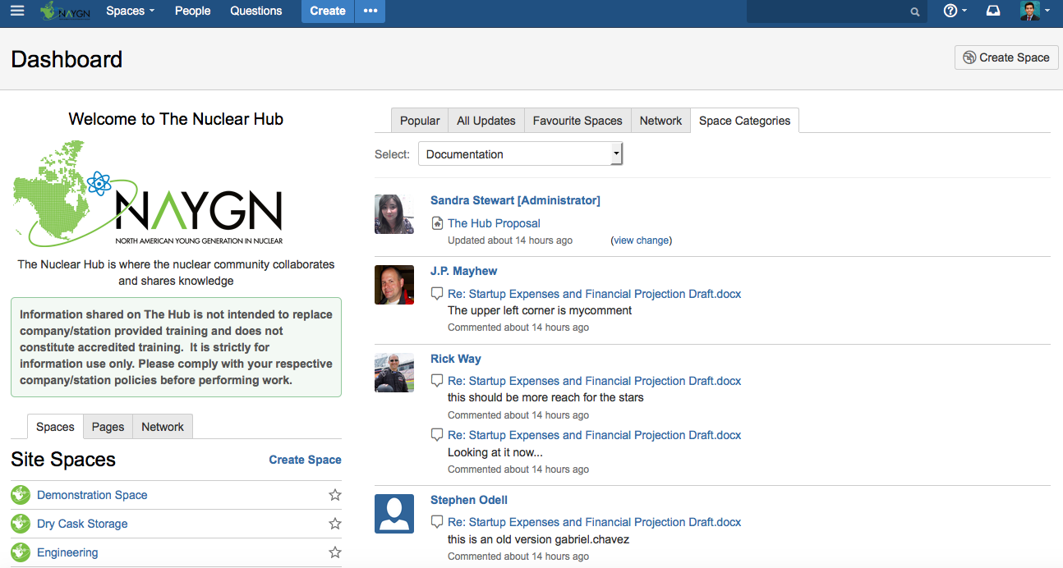

The Hub Dashboard on Confluence

Pilot Program

The pilot program will use a progressive invite model, starting with a small population of users and inviting other participants identified by NAYGN and the Steering Committee. These participants will champion the initiative at their respective sites and help generate content to populate the Hub. The local NAYGN chapters will serve as liaisons to help identify and establish connections with Subject Matter Experts for their respective fields, and steer them towards the Hub. The initial population for the pilot program will be 50 users; a user is defined by a unique profile and login credentials, with the ability to post and curate content on the Hub. With Confluence’s ability to view the Hub without logon credentials (anonymously), the Steering Committee can obtain valuable feedback from NAYGN members for improvement opportunities.

Pilot Program Abridged Timeline

* Mid-December – send out invites to the pilot participants
* Mid-January – initial meeting with pilot participants
  + Provide participants initial training on Confluence/Hub
* End January – Obtain participant feedback on pilot program goals for:
  + Content generation
  + Check-in frequency
  + Conference circuit strategy - marketing
* February – Pilot members start populating the Hub
* Pilot Program Monitoring
  + Monthly Check-ins
  + Steering Committee may increase frequency as needed
  + Quarterly reports to Hub stakeholders
* May – Potential exposure to the general NAYGN/NEA membership
* June – Participation from CNOs (new content)
  + The “etiquette” video
* July through November – Content generation/exchange
* November – Status update and metric review
* December – NSIAC meeting
  + Pilot Program Review
  + Evaluation of large scale implementation

Startup Expenses and Financial Projection

The Confluence platform offers various options for hosting the Hub. Confluence offers both monthly and one-time subscription fee options for their service. The monthly subscription option provides cloud based hosting for up to 2,000 users. The one-time subscription option (i.e. a perpetual license) provides the platform and service support for up to and in excess of 10,000 users. The perpetual license, however, requires the licensee to host on a Confluence Data Center or their own servers. The pricing options provide for an affordable way to manage a pilot program and easily scale to a fully operational program.

The initial stages of the Hub pilot will be performed using Confluence’s cloud based hosting. The initial funding required for the pilot program will be approximately $3,8001. This funding will provide licenses for an initial 50 users for 12 months. The pilot program will serve as a proof of concept that the Nuclear Industry can successfully use “crowd sourcing” to solve the industry KT&R problem. The pilot will help prepare the Hub for full launch, but also show the potential process gaps and flaws. Metrics will be established to measure the success of the pilot program: frequency of use, rate of new content generation, and feedback surveys, etc.

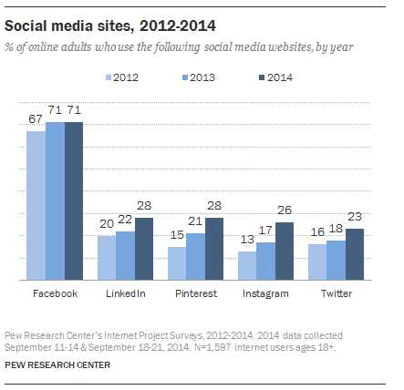**Financial Projection**

The costs detailed below were determined using social media trends and adoption rates from the Pew Research Center2. The average adoption rate for social media sites is approximately 20%, based on adult usage (e.g. 18 years +) of LinkedIn, Instagram, Twitter, etc. from 2012 to 2014. Recent surveys on Mashable.com show that interaction with most social media is frequent within the first year of initial roll out, and tail off afterward – with Facebook being the exception.

The financial projections consider the costs of the pilot program, as well as scaling to a fully operational program.

The assumptions for the pilot program are:

* Level of Effort by pilot participants
* Initial recruiting efforts will use local NAYGN chapters
* Pilot participants will be representative of the Industry (e.g . discipline, experience, etc.)
* Anticipate 2 – 4 hours (cumulative) of participation a month (e.g. establishing profile, posting content, asking questions, etc.)
* No marketing expenses, Nuclear Industry participants are expected to promote the initiative through corporate, site, and NA-YGN communications
* Initial expenses for pilot program may be covered through NAYGN

12-Month Projection

As stated previously, the pilot program will be done using Confluence’s monthly subscription model (cloud based). The cost for 50 users per month is $3001, and includes hosting and technical support. To aid in the editing and curating of AV content a VimeoPro account will be created, the subscription fee is $200 per year. For a 12-month pilot program the total cost comes to $3,800 and could generate up to 2400 hours of participation. Entergy will provide the funding for the pilot program.

In addition to the previous assumptions, the following is assumed for the fully operational program:

* 99 operating reactors across the industry
* Average of 600 employees per reactor3
* 20% adoption rate by all available employees; approximately 12,000 users
* Adoption curve\* was stretched across a four year period
* Expenses after the pilot program will be split across Utility/Industry participants

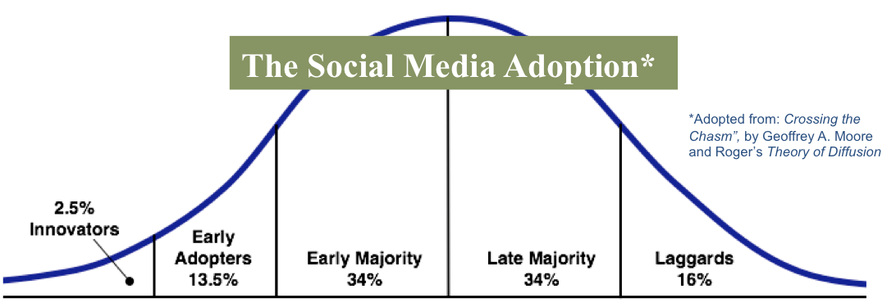

Four-Year Plus Projection

To generate a long term projection of the costs for the Hub the Nuclear Community was used as a benchmark, obtaining ~2,500 users in a four year period. A four year projection was assumed 2,000 users by the 4th year. Costs for the Hub will be minimized by maintaining a cloud subscription with Confluence through the initial growth period, as all software maintenance and technical support is included. If the Hub obtains a critical mass of users and grows at the pace of other social networks, the terminal costs assume the 20% adoption rate with a total of 12,000 users. The costs after the fourth year would assume a transition to a perpetual license while using a Confluence Data Center, as it would include capacity for up to 40,000 users. Confluence Data Centers include server maintenance and technical support; pricing for this deployment option is tiered with a cost of $120,000 per year for the first 5,000 users and afterward $10,000 per year for every 5,000 users1.

The long term projection assumes Confluence’s tiered licensing upgrade structure after the 4th year. Perpetual licenses are only valid for the number of users it was purchased for; upgrading to a higher tier requires the purchase of a new perpetual license. Since the price points between user tiers are so close, within 20%, obtaining a perpetual license for 10,000+ users will be the most cost effective option – at a one-time fee of $24,000. Software maintenance for perpetual license can be renewed at a cost of $12,000 per year1. Ultimately, the demand for new user accounts will determine when and which tiered user level will be purchased.

The projection below shows an estimate of the costs associated with the Hub. After the pilot program, the administration and miscellaneous line item is a 10% contingency of the sub-total for budgetary purposes.

|  |  |  |  |  |  |  |
| --- | --- | --- | --- | --- | --- | --- |
| Year | 2016  Pilot | 2017  Year 1 | 2018  Year 2 | 2019  Year 3 | 2020  Year 4 | 2021+  Nth Year |
| **# of users (Forecast)** | **100** | **500** | **1,500** | **1,700** | **2,000** | **10,000+** |
| Confluence Cost1,4 | $3,600 | $9,000 | $18,000 | $18,000 | $18,000 | $24,000\* |
| Hosting/Maintenance | -- | -- | -- | -- | -- | $142,000+ |
| Administration/Misc. | $200 | $900 | $1,800 | $1,800 | $1,800 | $16,600 |
| Total | $3,800 | $9,900 | $19,800 | $19,800 | $19,800 | $182,600+ |

\* Denotes a perpetual license, a one-time fee.

Implicit Benefits

The value of the Hub will depend greatly on the content it contains and the exchange of information that occurs between users. Its value is not something that can be readily measured, however, if it reaches a critical mass it can become integral in aiding the industry by:

* Preventing loss of knowledge
* Reducing impact to organizations after employee departure
  + Minimizing cost (time and resources) for hiring, training, mentoring, coaching or managing people within an organizational unit
  + Aid in succession planning
  + Enhance formal training through anecdotal information

There are many implicit benefits that underlie the idea of the Hub: a crowd sourced knowledge base, accessibility to a larger pool of people/SMEs, a unified platform to facilitate exchange of information, distance learning, etc. The goal of the Hub is not necessarily to realize any specific time or monetary savings for the industry but to facilitate knowledge capture and transfer. However, this can only be achieved through united support by NSAIC, NAYGN, and the rest of the Nuclear Industry.

Challenges and Mitigating Strategies

With an initiative such as the Hub, there will undoubtedly be challenges the Steering Committee and NAYGN will face during implementation. Some of the anticipated challenges with this undertaking are:

* Content
  + - Generation – getting individuals to create content on a frequent basis
    - Control – is the information proprietary, is it appropriate
    - Topics – creating content people want/need
    - Quality – consistency in the quality of people’s posts/media
    - Volume – having enough content to draw people in
* Usage
  + - Time – giving users the ability and time to use the Hub
    - Motivation – perceived/realized incentives to use the Hub
* Sustainability
  + Scaling – the ability to grow the Hub seamlessly
  + Industry support – Has the rest of the industry bought in, promoting the HUB
* Ownership
  + - Leadership - NAYGN
    - Structure – Long term, cross discipline, steering committee.

NSIAC Support

The Steering Committee needs the support from the NSIAC to make the Hub a reality and a successful KT&R platform. Primarily, support is needed to help promote the Hub and institutionalize it as a tool in their respective organizations. NSIAC can help communicate the value behind the initiative and identify potential pilot participants.

By rallying around the Hub the Nuclear Industry can capture and retain some of its most valued human and knowledge capital.