North Anna vs. Calvert Cliffs
Paintball
On Friday, May 12th, 2017 the NAYGN chapters of North Anna (NA) Power Station and Calvert Cliffs (CC) Nuclear Power Plant took some healthy rivalry to the paintball field. 25 participants met at Southern Maryland Paintball, with the intentions to demolish their opponents. Calvert Cliffs arrived early in the morning, based on the weather forecast to play a few warm up games against one another, prior to NA’s arrival NA took on CC for 3 team elimination style matches, on 3 different fields. Calvert easily defeated NA in all 3 matches, with very few Calvert players even being eliminated. Afterwards both NAYGN chapters headed over to Gilligan’s Pier for some much needed rest, networking, and libations. This event was a great opportunity for the neighboring chapters to bruise each other up while networking and exercising team building.
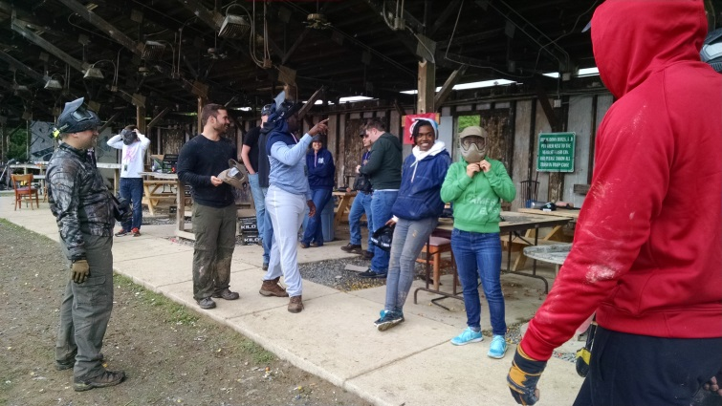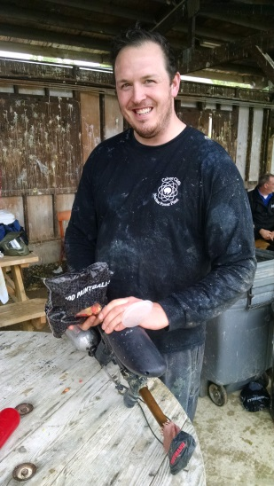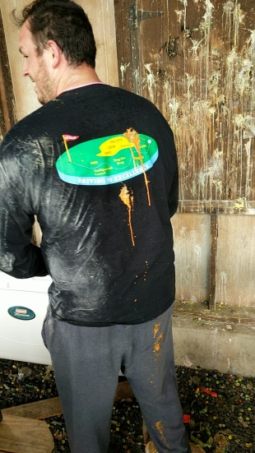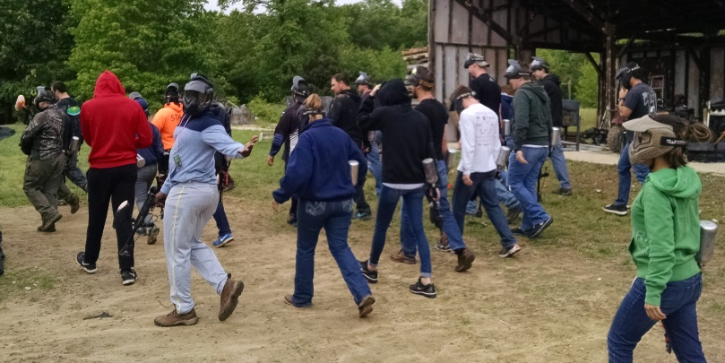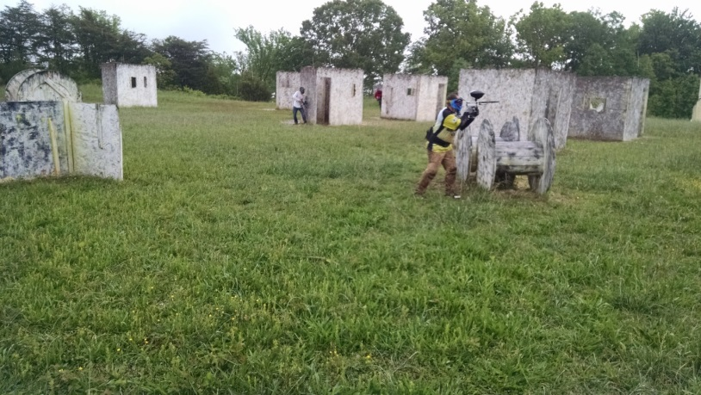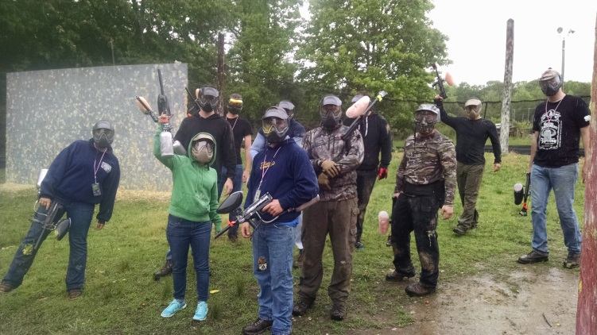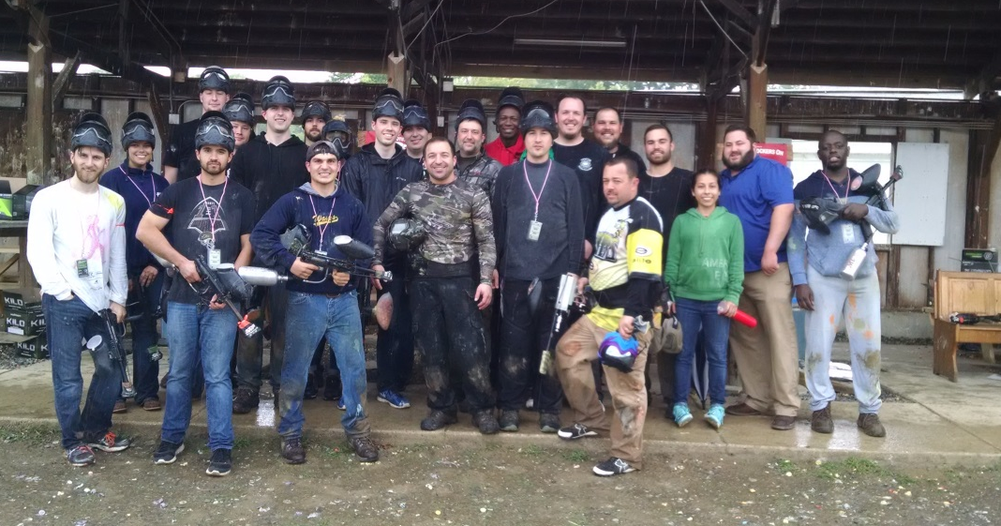

Norfolk Naval Base Tour
On Friday May 26th, 2017 the Calvert Cliffs Chapter of NAYGN participated in a tour of the Norfolk Naval Base facilities and nuclear powered submarine. Duty Chief Sotelo, tour guide, provided an overview of the experiences existing in the compact quarters of a nuclear submarine. Visitors viewed the living quarters, control room, and torpedo room. For security reasons, visitors were not authorized to see the reactor. However, the captain did disclose that the ship ran on a pressurized water reactor with high enriched fuel that extends the life of the hull, 35 years. The remainder of the tour was a quick ride through the base. Participants got a snapshot of various aircraft carriers, planes and office facilities. This was an awesome opportunity for members to experience a part of nuclear outside of commercial use. 