Make your Future: Get Involved!
Join the
North American Young Generation in Nuclear!

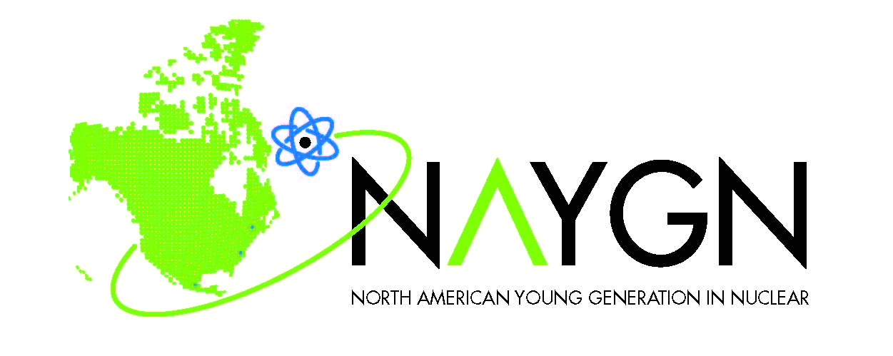

Kick-off Meeting
(Date)
(Time)
(Meeting Location)
Light Refreshments will be served!

You are cordially invited to meet members of the _______ section of the North American Young Generation in Nuclear (NAYGN), on (Date), from (start time) to (end time). The goal of this meeting is for you to learn more about NAYGN, meet other young professionals, and (add any other meeting objectives)
NAYGN was established in 1999 by a small group of young professionals across North America. NAYGN provides opportunities for a young generation of nuclear enthusiasts to develop leadership and professional skills, create life-long connections, engage and inform the public, and inspire today’s nuclear technology professionals to meet the challenges of the 21st century.
This mission has a number of goals:
1. Recruit talented young people into nuclear careers.
2. Retain young nuclear professionals in the nuclear industry (in whatever field) by providing professional development opportunities for them (a career versus just a job).
3. Facilitate the transfer of information and know -how between the pioneers of the nuclear industry that are starting to retire, and the new generation of nuclear professionals.
4. Be proactive and educate the public, the media and the policy makers about the true impact that nuclear science and technology have in their lives.
5. Unite the different fields of nuclear science and technology.
In this meeting we will discuss:
- What does NAYGN have to offer: how can NAYGN help you, your company and the nuclear community in general?
- (Insert other agenda items here)

For more information, please visit our website www.naygn.org. If you have any questions please do not hesitate in contacting (insert name and contact information)
Please RSVP to (insert name and contact) by (date), so we can plan accordingly.

