 |  | How You Can Help the Drawing Contest
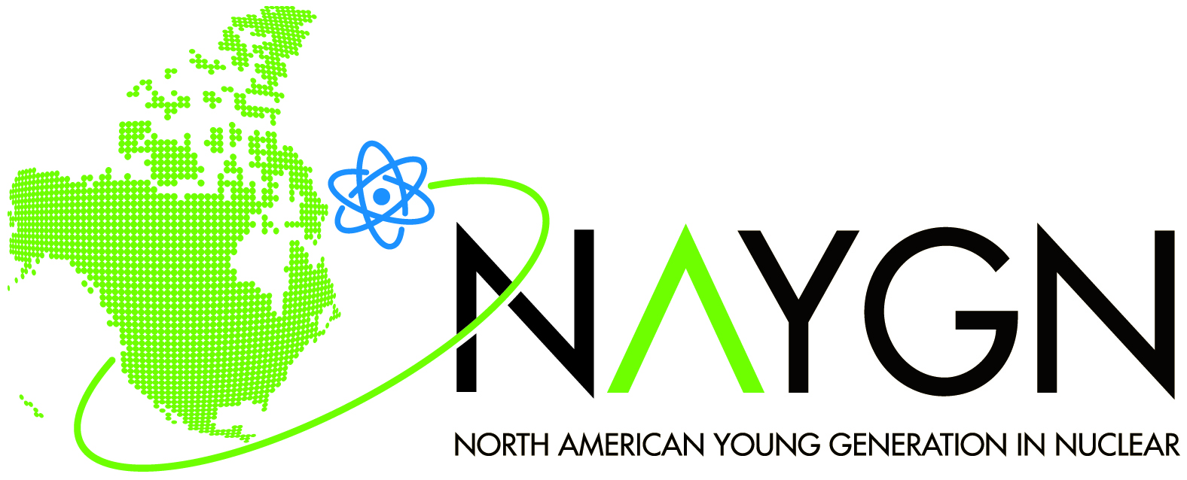 |  | How You Can Help the Drawing Contest
For NAYGN Members and Local Chapters
There are many ways you can help drive the future success of the NAYGN Drawing Contest! Build your leadership and organizational skills as well as your professional development résumé.

Presentation
We’re looking to perform a facelift on the presentation. Are you willing to help us develop a new presentation?

Theme
We’re looking for a fun new theme for our contest! Do you have any ideas?

Translation
Have you translated any of our materials into other languages? Please share them with us, so we can make them available to everyone!

Please contact us (use “Public Information” radio button) if you’d like to help out!

