Host the Drawing Contest
For Educators
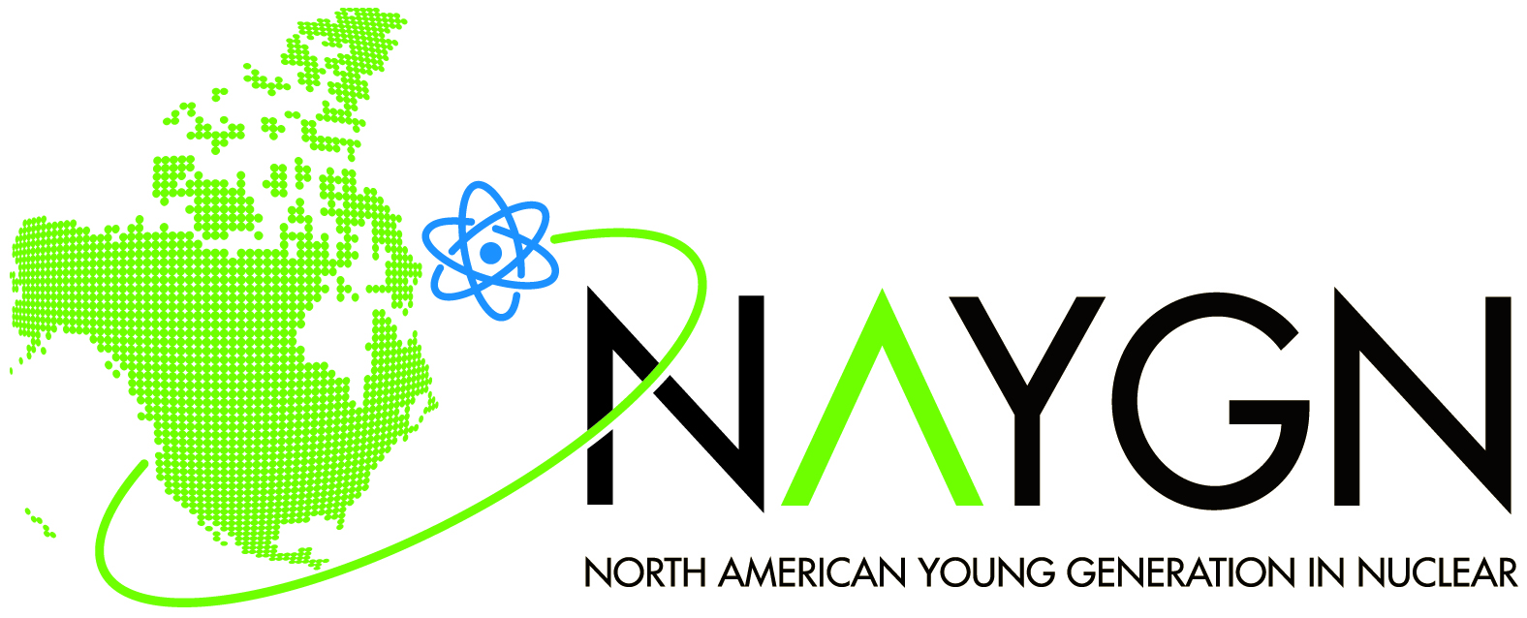 |  | Host the Drawing Contest  For Educators
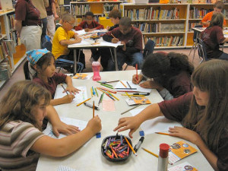
NAYGN is continually seeking to expand the drawing contest and other educational programs into additional schools, districts, and regions.

If you would like to host the NAYGN Drawing Contest at your school, or throughout your school district, please contact us at pi@naygn.com. We will match you with NAYGN members in your area who can talk to your students and coordinate the Drawing Contest at your school.

No local NAYGN chapter? No problem. You may submit up to 10 drawings for this year’s theme: “NuClear: the NEW Clear Air Energy” in *.pdf form to Naif Siddiqui at pi@naygn.org by May 13, 2022, along with the total number of students who participated, if applicable.
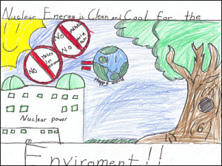
Original drawings should be on 8.5”x11” paper. For each submission, we need the following information: Student’s Name, School, City, State (or Province), Grade, T shirt size, and Teacher’s Name.

Please also contact us at pi@naygn.com if you are interested in other nuclear science and technology educational programs—we would love to work with you to develop a more specialized program to meet your students’ needs.

Thank you for your support, and we look forward to working with you!

Contestants are aware that the North American Young Generation in Nuclear (NAYGN) is a not-for-profit organization, which seeks to communicate with the public about the many ways in which nuclear science and technology have a positive impact in their daily lives and make important and valuable contributions to our society. By participating in the contest, contestants grant the North American Young Generation in Nuclear the right to print, publish, broadcast and use worldwide in any media now known or hereafter developed, including, without limitation, the World Wide Web, at any time or times, the drawing and the contestant’s name, as news or for public information and education on the benefits of the peaceful applications of nuclear science and technology without additional consideration or compensation. The drawing becomes the property of the North American Young Generation in Nuclear and will not be returned.

