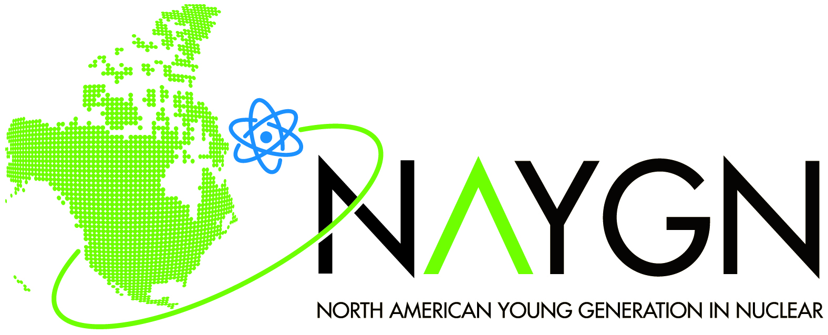 |  | Host the Drawing Contest
For Students and Parents
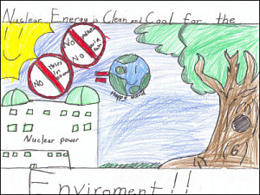
Do you want to participate in the NAYGN Drawing Contest, but your school isn’t currently involved?

Then talk to your teachers or school administrators, and tell them you want to participate in the NAYGN Drawing Contest! Show them this website and let them learn about NAYGN and our Drawing Contest.

Have a teacher or administrator contact us (use “Public Information” radio button) to locate a local NAYGN chapter that can kick-off the Drawing Contest at your school!

Also, please contact us (use “Public Information” radio button) if you are interested in other educational programs in nuclear science and technology—we would love to work with you and your teachers to develop a more specialized program just for you!

Good luck!

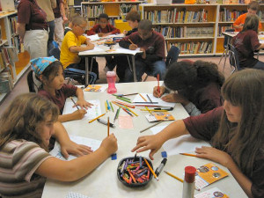

Contestants are aware that the North American Young Generation in Nuclear (NAYGN) is a not-for-profit organization, which seeks to communicate with the public about the many ways in which nuclear science and technology have a positive impact in their daily lives and make important and valuable contributions to our society. By participating in the contest, contestants grant the North American Young Generation in Nuclear the right to print, publish, broadcast and use worldwide in any media now known or hereafter developed, including, without limitation, the World Wide Web, at any time or times, the drawing and the contestant’s name, as news or for public information and education on the benefits of the peaceful applications of nuclear science and technology without additional consideration or compensation. The drawing becomes the property of the North American Young Generation in Nuclear and will not be returned.

