 |  | Guide to Participating in the NAYGN Drawing Contest
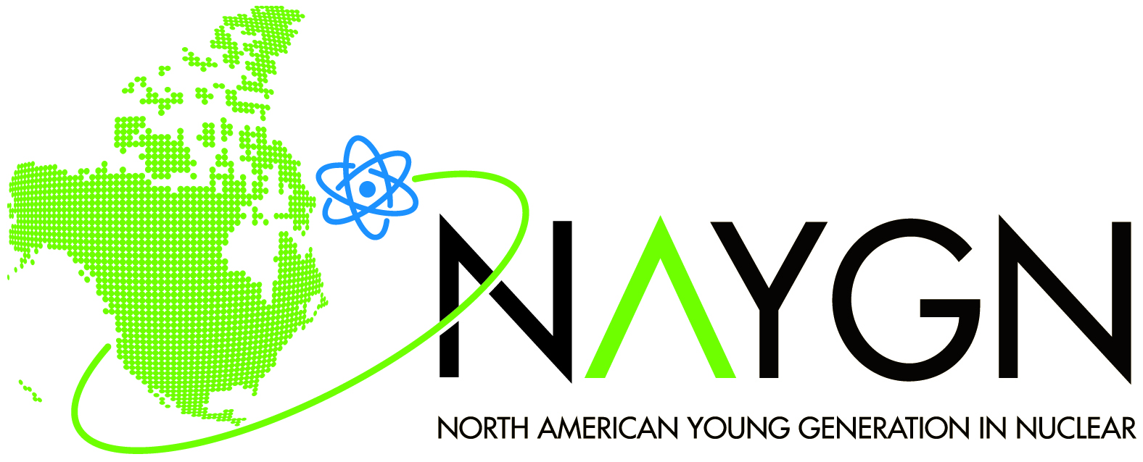 |  | Guide to Participating in the NAYGN Drawing Contest
For NAYGN Members and Local Chapters
The key to the success of the Annual NAYGN Drawing Contest is your participation!

All NAYGN members and alumni are encouraged to visit local schools to talk with students about the many ways in which nuclear science and technology impact our daily lives. Tell the students about the drawing contest and the prizes they and their school can win. Encourage them to make a drawing inspired by your presentation. Collect the drawings in a week or two, and submit them to NAYGN!

To make your life easier, we have developed some tips and a suggested timeline for planning your classroom visit (see next page) and some materials that we hope you will find useful. You are welcome to use them and customize them for your Drawing Contest needs! This is only a guide. Build your Drawing Contest around your local chapter’s schedule and needs.

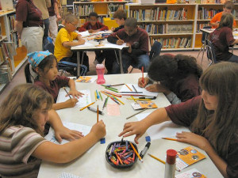

Suggested Timeline and How-To Guide
Pre-Planning  Three to Four Months Prior to Deadline  (July-August) |  | Contact the principal or a teacher at the school preferably by calling the school and explain NA-YGN’s mission and the purpose of the contest. Below are sample letters you may use for this first contact:  [English] 36KB, 2014  [Spanish] 36KB, 2014  Plan for long-term participation in the contest.  Consider focusing only on 4th graders OR 5th graders, so you won’t speak to the same set of students twice when your 4th graders become 5th graders next year.
Prepare Your Members  Two Weeks Before Visit  (Aug-Sept) |  | Ensure you have sufficient participation.  Classroom visits work well with two people—one to speak, one to give out goodies.  Reconfirm with teacher and review your schedule for the classroom visit.  We recommend 30 minutes on the presentation and 30 minutes to start the drawings.
Prepare Materials  One Week Before Visit  (Sept – early Oct) |  | Reference materials.  Provide three copies of the presentation and a CD for teachers to use as a reference.  Pre-formatted paper – Use this template.  Students fill in their information on the form side and draw on the reverse side.  Self-addressed envelopes.  If you will not be collecting the drawings yourself, make it easy for schools to submit drawings to you after the presentation.  Goodies for giveaways.  Rulers, pencils, and highlighters are great giveaways that help reinforce concepts when students answer questions. Ensure they will not be disruptive (e.g. noisy toys).
Your Classroom Visit  Day of Your Visit  (late Oct at the latest!) |  | Establish ground rules up front with the kids.  If you can't control them, you will likely not get an invitation next year.  Stimulate their minds.  Reinforce each slide by asking, “If you had to draw something, what would you draw?”  Reach the teachers to garner their support.  They’re the ones encouraging students to participate in the Drawing Contest! They’re also educating our youth, so we want them to know the facts about nuclear!  Use the Prezi presentation we have created especially for this purpose. Email pi@naygn.org to request the presentation.  You may need to make some minor updates to customize the presentation.  ** Add your name to the presentation.  ** French and Spanish speakers: Translate. Please share with “Public Information”!
Follow Up  Within a Week After Visit |  | Thank the principal and the teachers: a thank you note does the job!  Evaluate what you and your chapter can do better next year.  Transmit the top 10 drawings so that they arrive to the location below by the deadline.
Drawing Deadline!  November 7, 2014 |  | Upload your chapter’s top 10 drawings (in .pdf format), any photo or video taken during the classroom visit, and waivers for all children featured, to the PI Committee’s DropBox account:  Go to: http://www.dropbox.com  Login: pi@naygn.org  Password: pi2015  If you are unable to submit your materials via DropBox for any reason, please send them to Amanda Lang at Amanda.Lang@duke-energy.com.

