Michael Smyth 3/18/2022

Mechanical Engineering Supervisor

500 Townpark Lane

Kennesaw, GA 30144

To Whom It May Concern,

I write this letter to submit my name for nomination as NAYGN’s Technology Officer.

I have been involved in NAYGN for 9 years. Starting as an entry level member looking for a free lunch, I slowly learned about all that NAYGN has to offer its members, our industry, and the world.

Having served as Chapter Lead for ENERCON’s largest chapter out of Kennesaw, GA, I was introduced to the role of the NAYGN Board of Directors through the monthly Chapter Lead meetings. I was thrust into the inner workings of NAYGN after attending the national conference that year. I saw the energy that the Board of Directors and other Chapter Leads had for the initiatives of NAYGN, and I wanted to be a part of it.

I joined the Benchmarking Committee and was a key contributor on the 2020 Career Survey team and now am leading that committee as we prepare the 2022 Career Survey.

I became involved at the Southeast Region Level, was a part of multiple region initiatives, and spoke at the 2019 Southeast Regional Conference on the topic of Chapter Branding Best Practices. In 2021 I took over as Southeast Region Lead and spoke at our conference last year on the topic of the Role of NAYGN in Sparking Change in the Nuclear Industry.

While at ENERCON, I have helped our chapter and its members win multiple Excellence Awards and bolstered our chapter’s presence on the national stage in areas such as public information, community service, and networking culminating with winning Best Chapter in the Southeast Region for my last term as Chapter Lead. I am excited for the opportunity to grow the NAYGN organization and utilize my energy to advance its initiatives.

I believe my roles in NAYGN to this point have suited me well to elevate into the role of Technology Offer. I am excited for what I can bring to the role and the NAYGN Board of Directors.

Thank you for this opportunity and I look forward to working together in the future!

Regards,

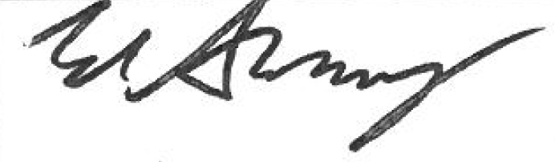

Michael Smyth