Help a little girl named Marie make a big impact in nuclear outreach when NAYGN releases its original children’s book, “Marie’s Electric Adventure” this September!

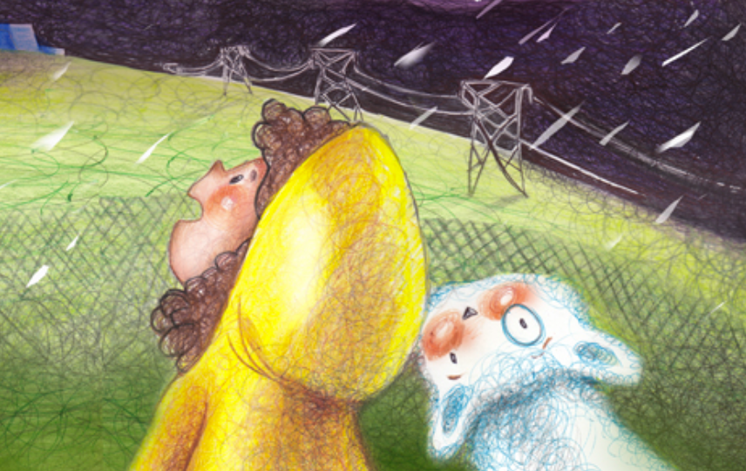
Thanks to Duke Energy’s chapter for creating this masterpiece to share with our communities to build positive relationships! Currently, the national team is working hard to develop a toolbox to minimize prep work and allow every local chapter to effortlessly utilize the book for maximum impact.

By now you have seen the survey requesting how many books your local chapter will receive. Those books will be mailed directly to your LCL at least one week prior to National Science Week (October 16 – 20, 2017). However, a webinar will be held mid-September to demonstrate hands-on activities to complement the book and lesson plans to share with teachers. We will also have a discussion to help generate a target audience list as well as suggestions on book distribution. Classrooms, girl scouts, libraries, families in need; the possibilities are endless and we will encourage volunteers to leave a copy of the book behind so it can be shared again and again.

Releasing over 3,000 books to our NAYGN troops is only the beginning! An e-book version will be available through Amazon, which will allow teachers to utilize the book free of charge in their classrooms! Limited hard copies will also be available for purchase through Amazon.

Please do not give these sample books to employees to take home to their children.
The purpose of these books is outreach and we want them to reach far and wide.
(Outside of those in the industry who are probably pro-nuclear already!)

This is the perfect opportunity to reach a key target audience- young females, so let’s work together to help spread Marie’s message that you don’t have to be afraid of the dark or nuclear energy because nuclear is a safe, clean and friendly way to light night lights and cities across the globe. And while we are at it, we can remind them that STEM can be fun, even for little girls!!!
Content Development  Amanda Lang  Andy Kalchik  Anne McGovern  Glen Lawson  Matt Bradfield  Adam Reichenbach  Kyle Hemker | Project Planning  Christine Johnsen  Alyse Scurlock  Ashley Marlowe  Jennifer Taylor  Meaghann Zeiner  Seth Weir | Roll Out  Theresa Widger  Natalie Wood  Jessica Nissenbaum  Bentley Sloan  Aleta Lane  Chris Wolfe
Much appreciation for the countless individuals (members, children, friends) who provided feedback every step of the way on this project.
A special thanks to Bristol Hartlage for sharing the idea of a nuclear children’s book with the Core at the 2016 NAYGN conference.
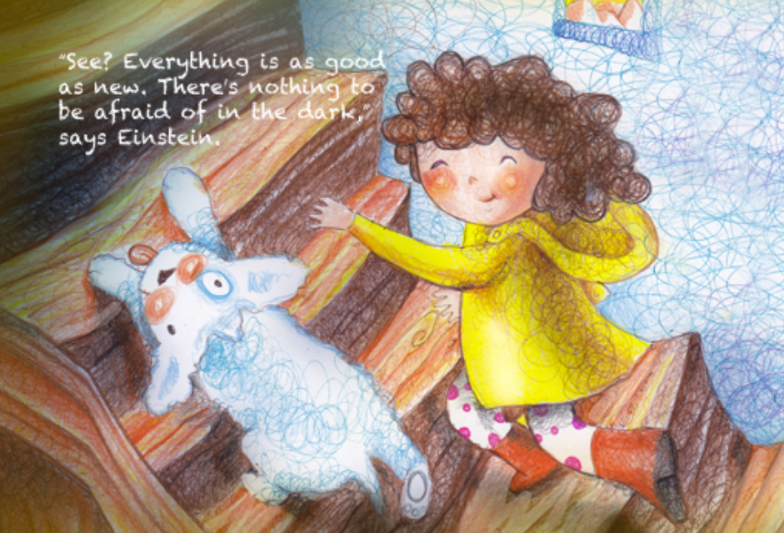

KEY POINTS
- Sample books will be delivered before October 9 to LCLs who responded to the survey.
- Mark your calendar for the informational webinar September 12 @ 2PM ET and official ‘book launch’.

ACTION ITEMS
- Share Marie’s story! http://naygn.org/maries-electric-adventure-a-childrens-book/
- Set up classroom readings for National Nuclear Science Week October 16-20, 2017. Target group is Kindergarten through Second Grade.

CAN’T GET ENOUGH OF MARIE?
- NAYGN owns the content and characters associated with Marie’s Electric Adventure and additional printings of the book are possible starting in Fall 2017. (Contact Amanda.Lang@duke-energy.com for questions)
- Limited copies of the book will be available on Amazon.com (with Prime shipping!)

CONTACT INFORMATION
Please contact Amanda Lang (Amanda.Lang@duke-energy.com) with any questions or comments.

