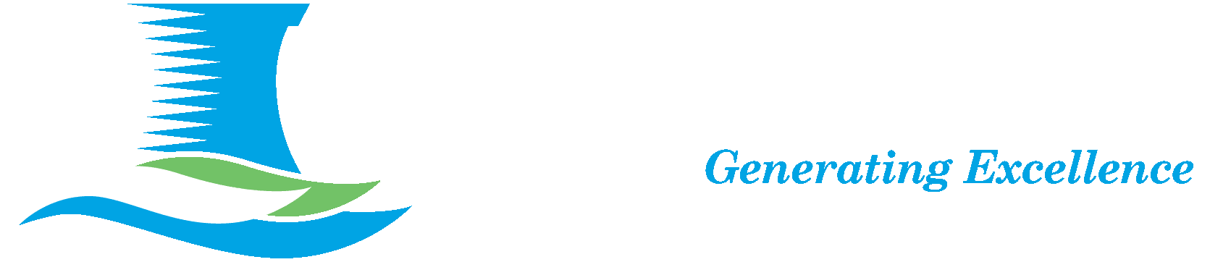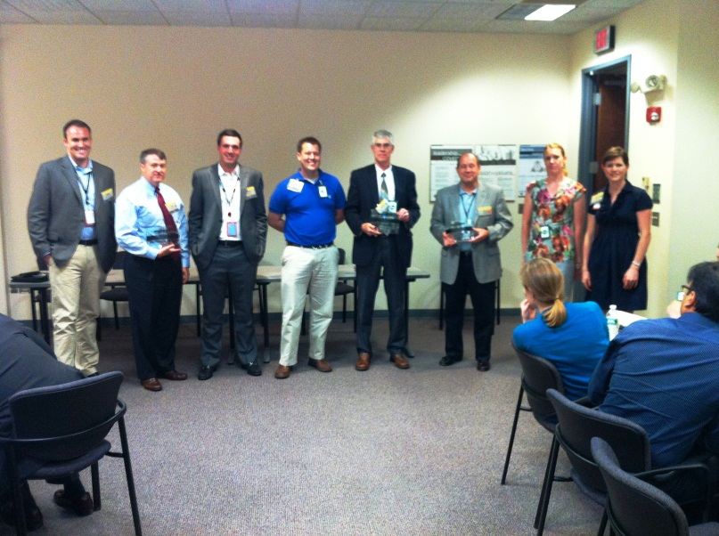

MONTHLY

NA-YGN

Newsletter

At SSES

this issue

NA-YGN Atlantic RegionalConference 2012 **P.1**

Member Accomplishments **P.3**

Upcoming Events **P.4**

**NA-YGN and**

July

2012

Pictures from the regional conference held in June

*Dr. Andrew Cook (right), the Senior VP of Operational Excellence and Innovation at AREVA, was presented this award for his involvement at the conference.*

*Brittany Sprung (left) PPL Susquehanna, and Jim Ransom (right), Principal Project Manager at AREVA, NP.*

*Nate Bennet (left) presents Bobby Ashworth (right), Atlantic Regional Lead,, with an award for his effort to help arrange the conference.*

01

ISSUE

**NA-YGN at SSES** Issue 01 July 2012

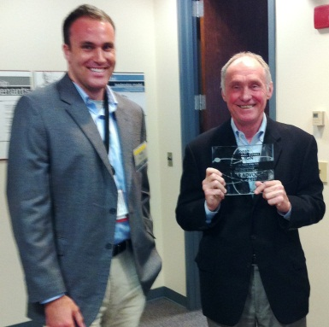

2012 NA-YGN Atlantic Regional Conference

Brittany Sprung

He opened with the issue of global electricity demand expansion, and transitioned into the importance of energy independence and diversity over the next 20 years, and compred the safety record of nuclear the nuclear power industry against other electric power industries. The safety record of the nuclear power industry far outshines all other industries.

In addition to the guest speakers, the networking and socialization aspect was outstanding. The conference had representation from a variety of companies throughout the industry, including generation stations, design companies, technical consultants, and ISD vendors. It gave everyone a chance to exchange experiences and gain some insight to the various careers available in the nuclear industry. The conference social function was held at Fredrick Cellarswith food catered by Black Hog (BBQ).

I consider the 2012 regional conference a complete success and look forward to other NA-YGN events and activities. The content was enriching, and all attendees were actively engaged. For me, it was 2 days filled with professional networking and information that will enhance my abilities as a nuclear professional. A big thanks to the Atlantic Regional Event planning committee.

Over the weekend of June 22nd, NA-YGN held its Atlantic Regional Conference at the Bechtel Corporate Offices in Frederick, MD. NA-YGN enhances the capabilities of its members by bringing the new generation of the nuclear industry together for technical education and networking opportunities. Members of NA-YGN in attendance at the Atlantic Regional Event came from Bechtel, AREVA, PPL, CENG, Calvert Cliffs NPP, Transnuclear, MPR Associates, Westinghouse, Shaw Group, and IBEX Engineering Services..

The conference had 5 highly regarded guest speakers that provided their insights about the Nuclear Power Industry: Dr. Andrew Cook, the Senior VP of Operational Excellence and Innovation at AREVA Inc., Mr. Jim Ransom, Principal Project Manager at AREVA NP, Mr. Mark Finley, Senior VP at UniStar Nuclear Energy, Mr. Stephen Veale, VP Bechtel Power Corp., and Mr. Brian Meeley, with Potomac Communnication Group. Each of the speakers received an award for their contributions to the conference.

Conference topics included current events in the industry, new plant siting and licensing practices, nuclear ethics, industrial safety performance, and how to communicate with the public about nuclear technology. The conference modules consisted of both speakers and interactive sessions. Dr. Cook, the first guest speaker, provided a particularly captivating presentation.

