How to build your own Build-a-Bundle

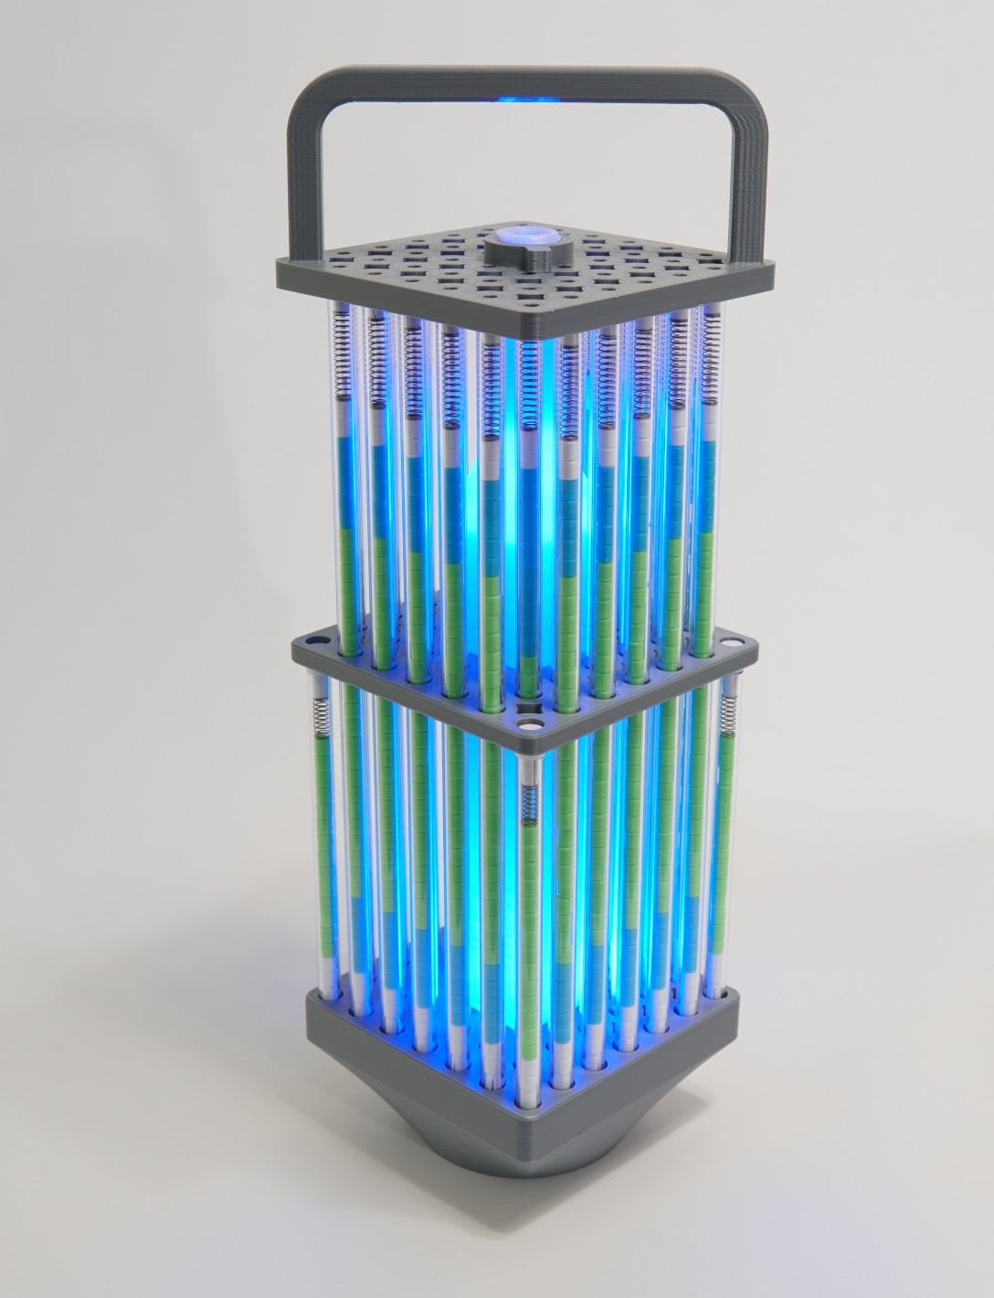
The Build-A-Bundle activity was created by the Framatome-Richland NAYGN chapter. With this activity students get to try their hand at manufacturing a nuclear fuel assembly and gain a better understanding of nuclear fuel and fuel products.
The activity takes students through the manufacturing process from pellet production to final assembly and inspection. Using coffee creamer dyed with cake decorating powder, students press pellets using a hand press. Once the pellets are pressed, the students are then challenged to inspect the pellets, remove any that don’t meet quality standards, and insert them into the rods in the correct arrangement.
The students must then load the completed rods into the lower tie-plate and insert the end cap. A group of students visually inspect the rods to ensure they have the correct enrichment (pellet colors) in the rods. If inspection is “successful,” they can place the upper-tie plate over the rods, completing the final assembly.
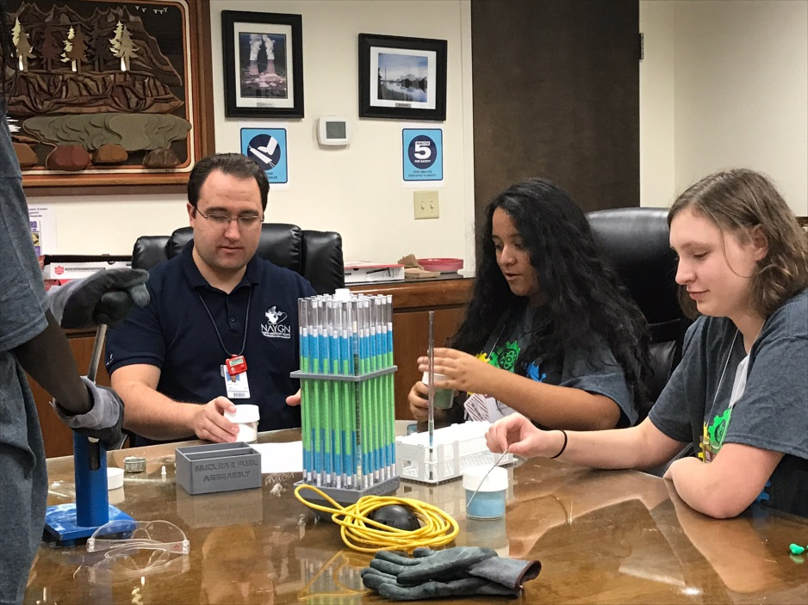

In order to build your own Build-A-Bundle activity the following instructions are provided:
1: Download the following files:
- Lower_Tie__Plate_decimated.stl
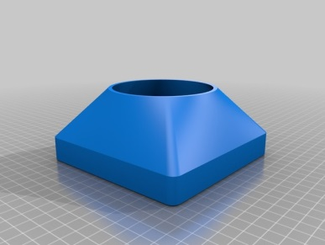
- Water_Channel_decimated.stl
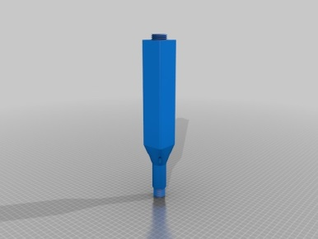
- Upper_Tie_plate.stl
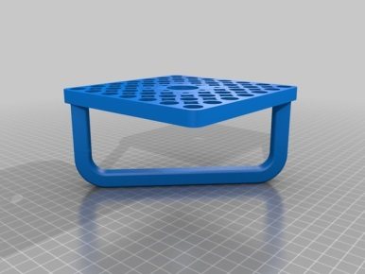
- Spacer.stl
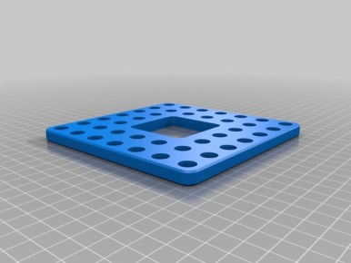

- Short_Nut.stl
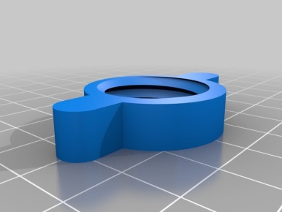
- Cap_Upper.stl or Cap_Lower.stl
(We found the plastic tubes are not very uniform. You may need to experiment with the caps to get the correct fit. Or, for a cheaper alternative dry wall screws also work)
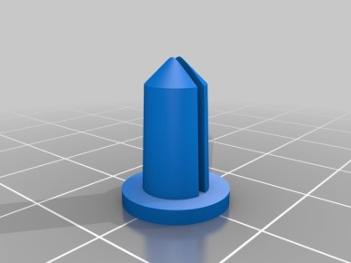
- Pellet_solid.stl or pellet_array_169_pieces.stl
(A total of 1,440 pellets are required to fill all of the rods. An array of 169 pellets is provided which may help with cost if having someone else prints the parts for you)
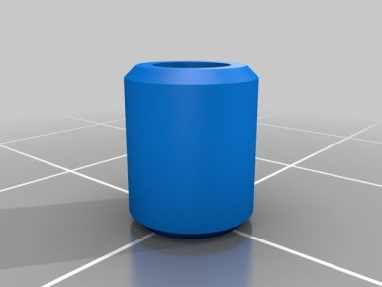
2: Print the plastic parts
If you have a 3D printer you can print the parts yourself. We found the eSUN PLA Pro material worked well printing at a 0.1mm layer thickness. If you want your Bundle to be able to light up, you can print the water channel with 3D Solutech PETG in clear.
If you do not have access to your own 3D printer you can upload the files to several websites that will print the parts for you. We’ve used shapeways.com and found it to be pretty good. We printed most of the parts in PLA, the water channel in Strong & Flexible, and the pellets in sandstone. Expect to pay around $600 to have shapeways.com print the parts for you. You can get a discount if you have a student e-mail address.
3: Order tubes and springs
The clear plastic tubes and springs can be ordered from MSC. You will need 40 clear tubes and 40 springs.
https://www.mscdirect.com/product/details/63405914
https://www.mscdirect.com/product/details/03307923
4: Optional extras
Pellet Press
A 6mm pellet press can be purchased so that you can press your own pellets. These can get very expensive. We have found a Chinese built pellet press that works fairly well and cost us $150. You can find this on a phone app called Wish. Search for “pill press” and make sure you get the 6mm pellet version. We found that coffee creamer works very well for pressing and you can add cake coloring powder if you want to make the pellets different colors.
Carrying case
In order to carry your Build-A-Bundle we found that a carrying case is very useful. We ordered the Pelican Storm Case iM2700 and found it to be about the perfect size.
LED lighting
There are 8 holes at the bottom of the water channel that you can glue in LED lights. We have some simple wiring, a 9V battery, and a switch that are glued inside the lower tie plate. With a clear water channel the whole Bundle lights up. It looks pretty cool.

