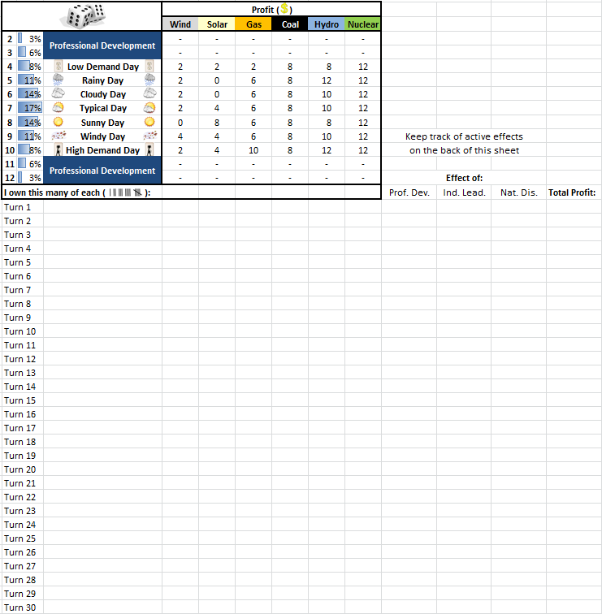

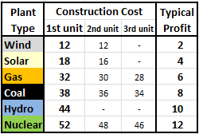

**Industry Leader Effect** (only one is active at a time, mark which one is currently in effect):

________ Carbon Tax Coal earns $2 less and Gas earns $1 less

________ Nuclear Waste Repository Nuclear pays $2 to repository each turn

________ End Govt. Subsidies Building new Wind and Solar costs double

________ Ban Fracking Gas earns $2 less

**Current Professional Development Card Effect:**

________ Industry Leader (See Above)

________ MW Fever Double profit for odd rolls, zero profit for even rolls

________ PE Extra $1 for every unit

________ SRO Extra $2 for every nuclear unit

________ Good Handshake That’s the stuff right there

________ Well Dressed Everyone come see how good I look

________ Good Networking Can split the cost/profit of new plants with other

Good Networkers

**Lasting Natural Disaster Effects:**

Nuclear AccidentNuclear costs $4 more permanent

Coal Mine Collapse Do not pay Coal (1 turn) __

Gas Shortage Do not pay Gas (3 turns) __ __ __

Volcanic Eruption Do not pay Solar (3 turns) __ __ __

Earthquake Do not pay Nuclear or Gas (1 turn) __

Tornado No lasting effects

Dam Break No lasting effects

Drought Hydro earns half, Solar earns double

(3 turns or until rainy day) **__ __ __ or** http://www.iconki.com/icons/Nature/Weather/40.png