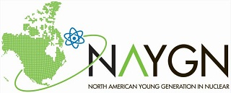
<Insert Legislator Name>
<Mailing Address>

Dear _INSERT LEGISLATOR NAME___,

The <Insert Chapter name> is pleased to share with you that the Nuclear Industry has announced this year’s Top Industry Practice (TIP) Award winners and the North American Young Generation in Nuclear (NAYGN) Organization is recipient of a TIP award for their work in making the nuclear power industry a safer and more efficient industry. Through NAYGN’s leadership, NAYGN has assisted companies in maximizing the value of their nuclear assets, including the ones in your district. NAYGN rolled out a multi-year initiative called the NAYGN Impact, which was created to improve efficiency while also advocating for nuclear energy facilities to be fully recognized for their value. One of the results of the NAYGN Impact was the creation of a children’s book called Marie’s Electric Adventure. 10,000 hard copies of the book were printed to support National Nuclear Science Week and was read to over 7,000 students across the United States and Canada. Marie and her dog, Einstein, have become a household children’s story and demonstrate one of the many innovative ways that NAYGN helps to educate youth on the importance of clean, safe and reliable nuclear power.
This Award will be presented in Atlanta, GA at the Nuclear Energy Assembly on May 22, 2018. With a few weeks left in the legislative session, we hope you will share with your colleagues the recognition that this group of young professionals is doing to impact their local communities, schools and larger country.

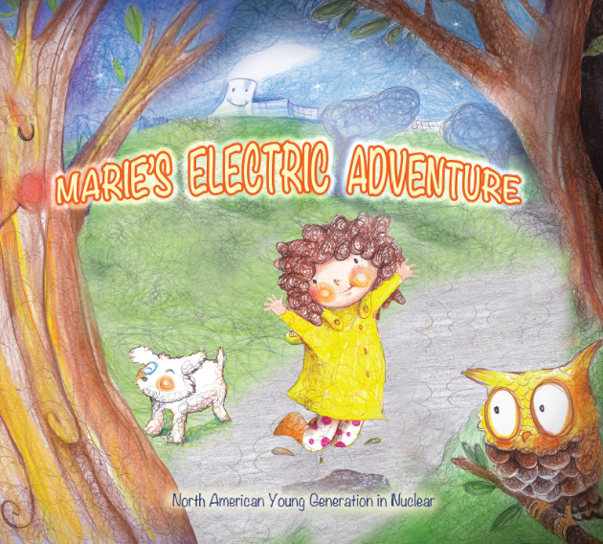
We look forward to hearing from you and appreciate your continued support of great organizations impacting our local communities and industries.

Sincerely,

<Insert Chapter Lead Name>
<insert email address, phone number and mailing address>

