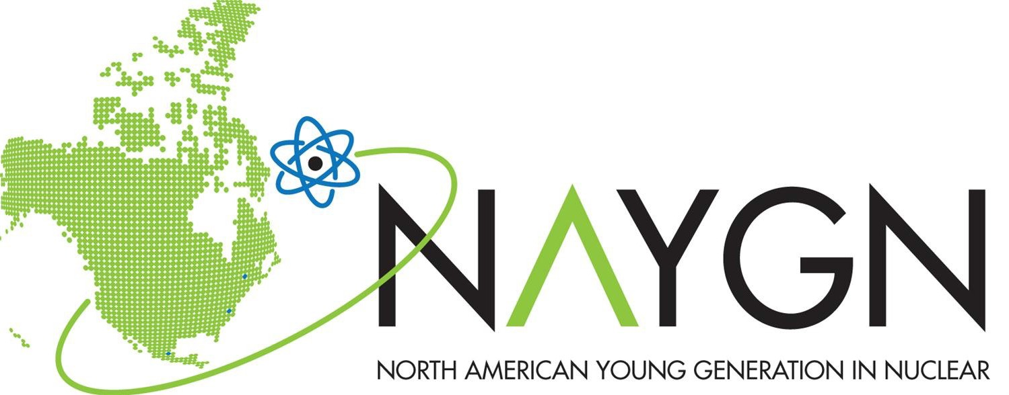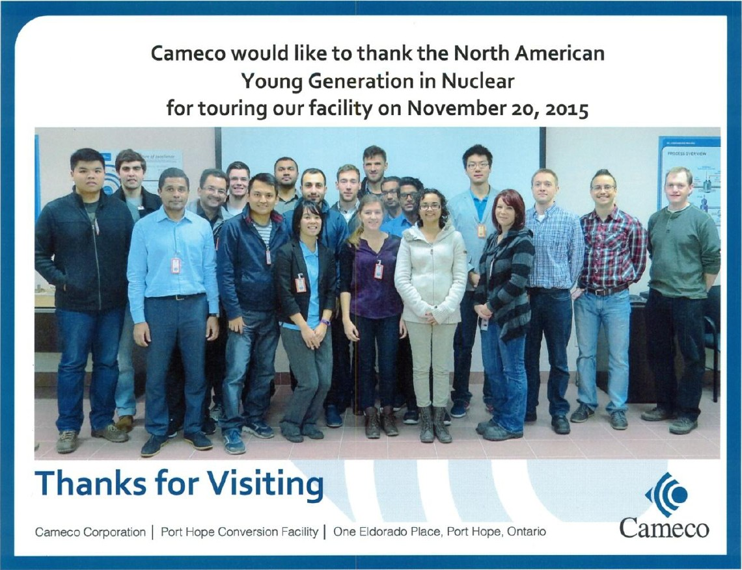Keep in touch
Cameco facility tour 2015

NAYGN Durham Chapter is never far away if you wish to know what we are up to. Just keep an eye on our social media accounts and contact us for any questions/inquiries you may have regarding our events and activities. We hope to
see you at one of our gatherings soon! Durham Chapter

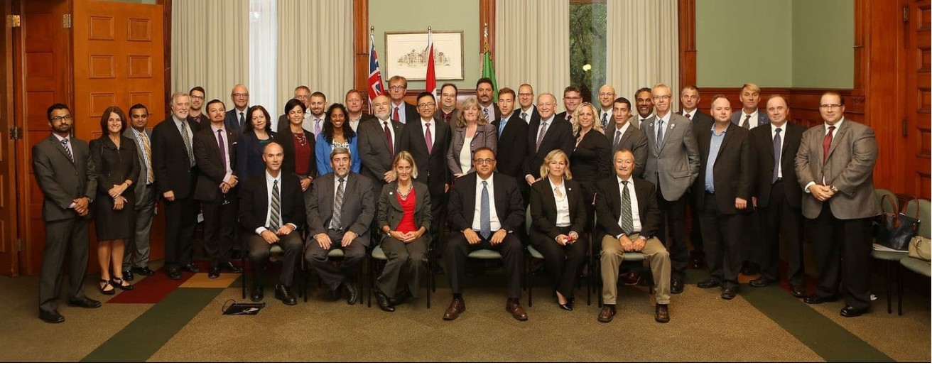 NAYGN Durham Chapter @naygndurham
@NAYGN_Durham
Developing leaders to energize the future of nuclear power

Nuclear Hill Day at Queen’s Park

NAYGN Durham Senior Executive Team (2017-19)

Matthew Mairinger - President
- Michael Saliba - Vice President
- Mark Goodchild - Treasurer
- Tanvir Ahmed - Communications Chair
- Karissa Palinka - Membership and Networking Chair

- Nadia Temacini - Community Outreach Chair
- Diana Urrego - Public Relations Chair
- Elise Lagacé - Professional Development Chair
EMAIL: naygndurham@opg.com
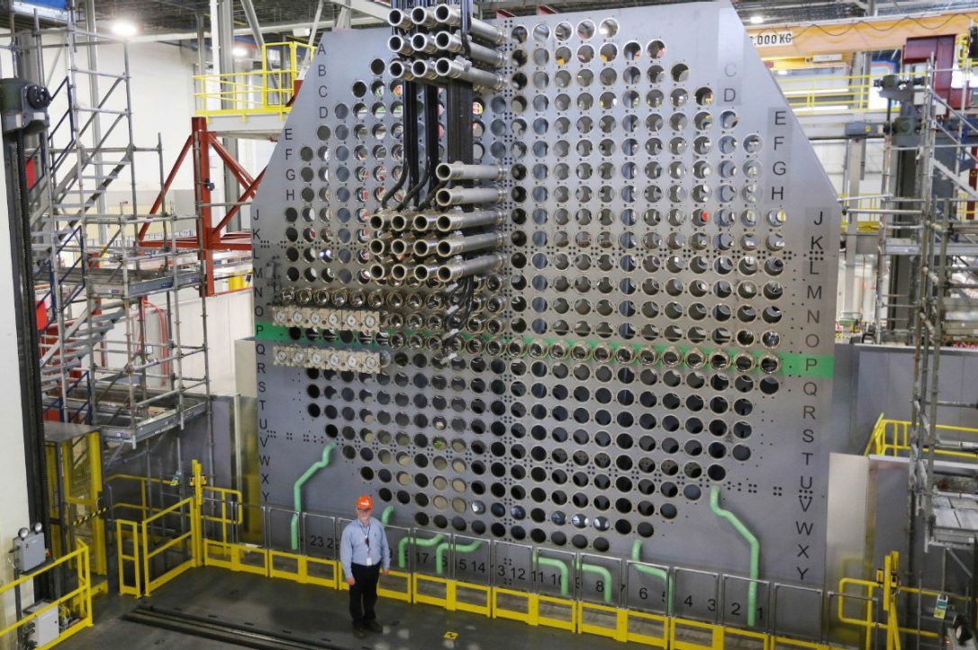WEBSITE: www.naygndurham.com

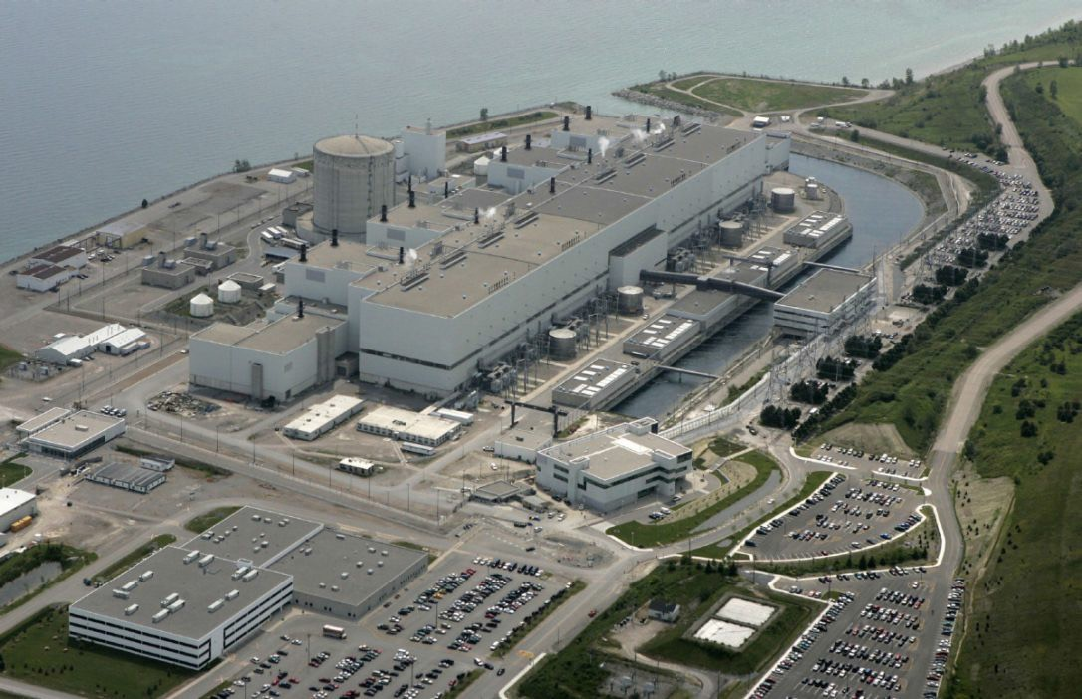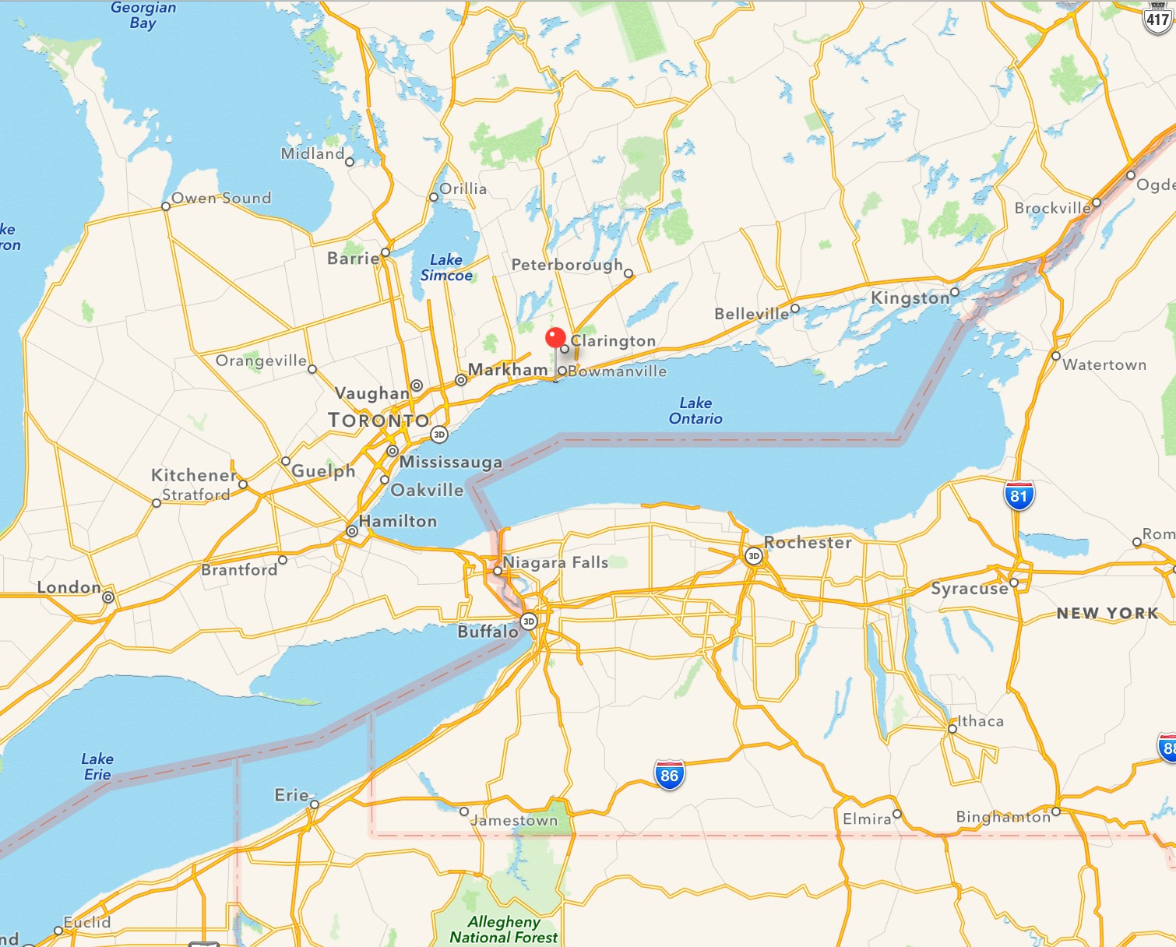Location: East of Toronto, Canada

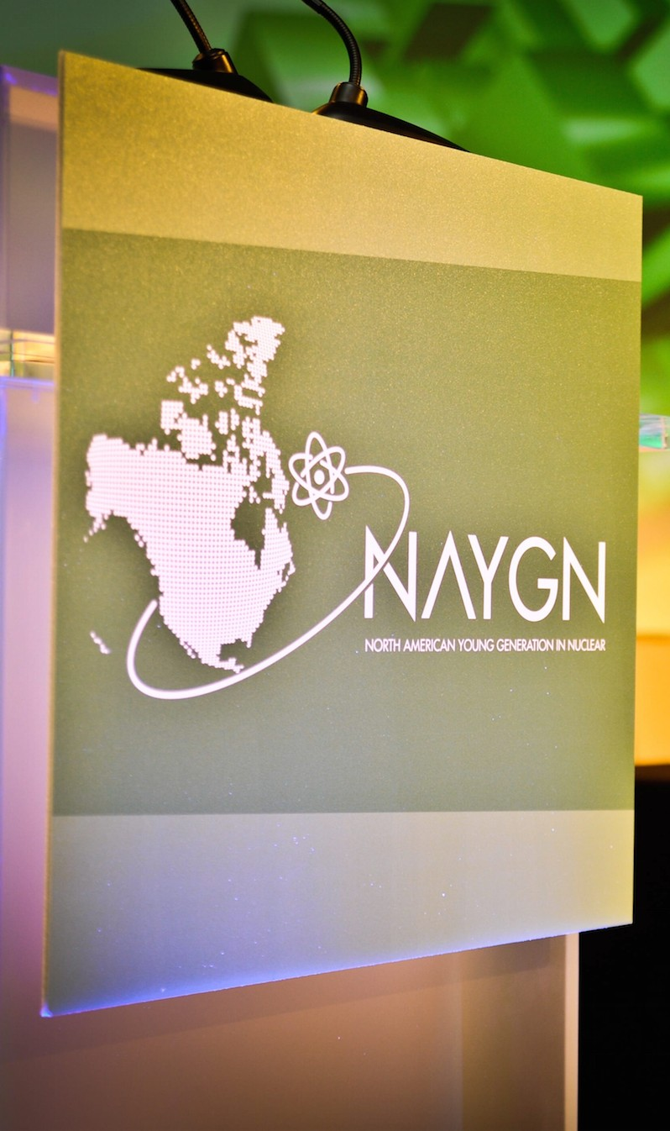Largest and most active NAYGN chapter in Canada serving nuclear technology professionals and the public

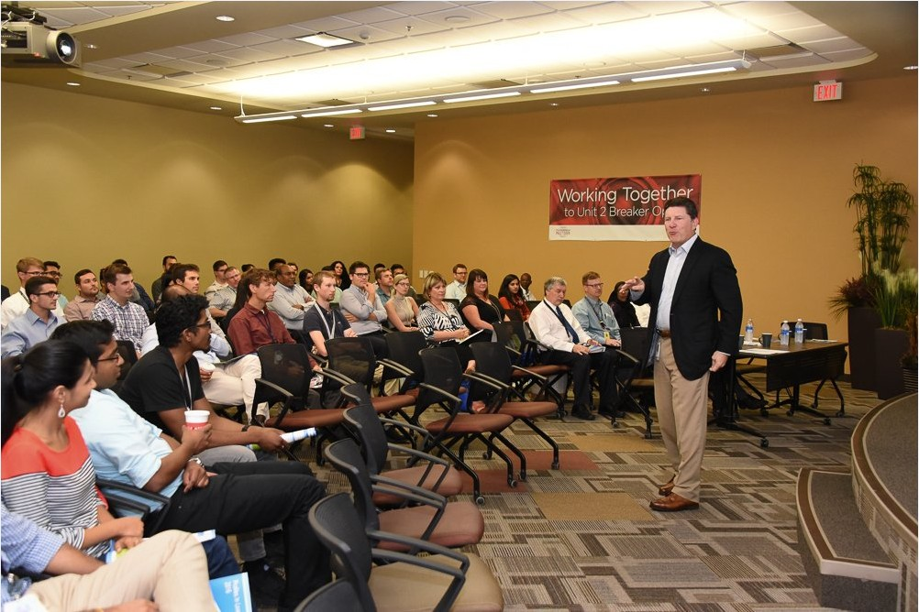
OPG CEO at Profiles in Leadership Event 2016

About us
Keeping in line with the motto of our parent organization, NAYGN Durham provides opportunities for a young generation of nuclear enthusiasts in the Durham region to develop strong leadership and professional skills, create life-long connections, engage and inform the public, and inspire today’s nuclear technology professionals to meet the challenges of the 21st century.

NAYGN Durham started its journey in 2008, 9 years after the core North America group was formed. The organization is composed of members from the 10 CANDU nuclear units (Darlington and Pickering stations) operated by Ontario Power Generation.
Our structure allows us to be flexible and serve a wide variety of members. Since initiation, we have been deeply involved in engaging and increasing participation of professionals from diﬀerent aspects of the nuclear industry in the Durham region. We spend our time and eﬀort to organize activities to educate the public and provide development opportunities at the local and regional level.

Events and Activities Highlights
- Seminars in leadership, lunch and learns on technical topics and valve workshop training sessions

- Facility tours for members such as CAMECO fuel processing facility, McMaster research reactor, and Chalk river laboratories

- Participation in Canadian Nuclear Safety Commission Public Hearings and at political Nuclear Hill events

- Networking events such as the annual regional Blue Jays game

- Semi-annual Operation Clean Sweep events in which volunteers help local community residents with their yard work

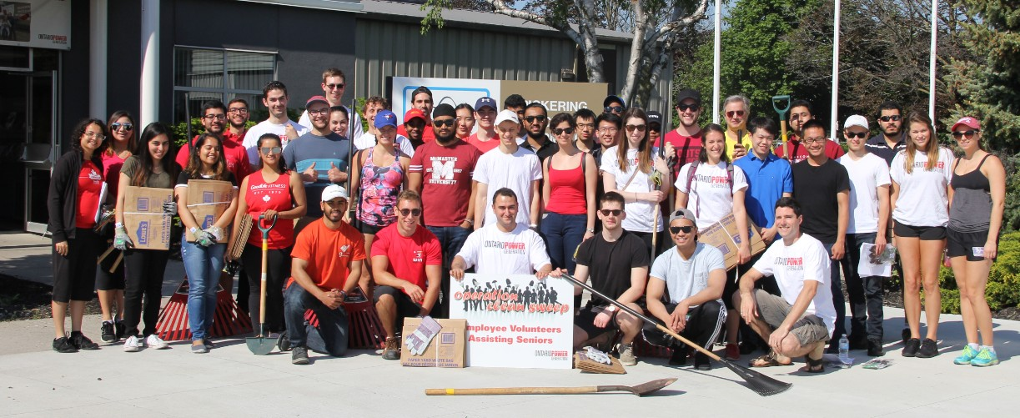
Operation Clean Sweep Spring 2017

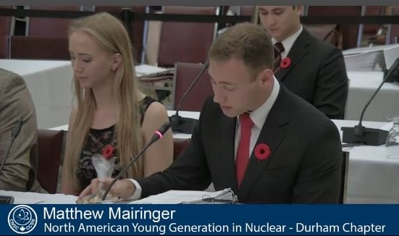
CNSC Public Hearing

