# Radiation

1. **How does radiation exposure actually cause death?**

Radiation is tiny particles with energy (they are moving!)

They are so tiny that they can move through some things (some can even penetrate your skin)

Radiation can break off a piece of DNA (adenine/thymine or guanine/cytosine pairing)

⇒ usually, this has no effect (your body repairs itself)

*Sometimes there could be a double break or an incorrectly replaced DNA molecule which leads to the death of the cell or the cell to do something else it isn’t supposed to (such as divide very quickly)*

When somebody is hit by a VERY HIGH dose of radiation, too many cells die at once and your body can’t keep up with replacing these cells

If the bone marrow dies (this is where cells are made), the patient is in need of a bone marrow transport

The majority of exposures starting at 300 rem are lethal.

Note:  NRC limits public to 1 rem per year; workers 5 rem per year

200-300 rem  - lethal for 10-35% of patients

300-400 rem  - lethal for 50-70% of patients   **marrow and intestine destruction

400-1000 rem - lethal for 60-90% of patients

1000-5000 rem - lethal for 100% of patients

<http://www.atomicarchive.com/Effects/radeffectstable.shtml>

1. **Are animals impacted by radiation in the same manner as humans?**

Yes!  Animals have DNA too!

Note:  in the HBO Chernobyl show, pets were killed to “prevent the spread of radiation”

Really, the pets could have been given a bath to get the contamination out of their fur and they would have lived normal lives.

Domesticated animals left to run wild would have entered food chain (this does spread contamination)

Note also:  the exclusion zone is now a “wildlife” zone of sorts - there are lots of flora and fauna that are thriving in the absence of humans

1. **If people survive radiation exposure, could there potentially be an impact to the off-spring of pets and humans?**

Generally, no.

Acute radiation syndrome patients ARE NOT CONTAGIOUS.

The patients from Chernobyl were not themselves radioactive (after their clothes were removed and they showered).  The patients from Chernobyl were EXTERNALLY exposed.

If patients ate highly radioactive sources (one case of this happening in Brazil), the patients might need to be isolated from others.

As for offspring, several hundred pregnant women were exposed to high dose radiation from the atomic bombs.  Of all these cases, only 29 children were born with attributable developmental defects. All of these cases were exposed in the second trimester, when cells are migrating to the brain from the neural crest.  <https://cancerletter.com/articles/20190524_3/>

The younger you are, the more your cells are going to divide in your lifetime.  Therefore, young people (particularly fetuses) are more sensitive to radiation. Generally when a nuclear employee is pregnant, they wear a special dosimeter to monitor the dose to the fetus.

1. **Does radiation cause cancer?**

Yes.  But, overall radiation is a fairly weak carcinogen.  There are so many other activities and factors that increase your risk of cancer much more!

Note:  Rule of thumb:  5000 mRem (5 Rem) equates to a 0.5% increased risk in cancer

Average liquidator:  12,000 mRem (12 Rem)

Average member of evacuated population:  3,000 mRem (3 Rem)

Average person living in contaminated lands:  1,000 mRem (1 Rem)

Women:  38%

Men:  40%

<https://www.cancer.org/cancer/cancer-basics/lifetime-probability-of-developing-or-dying-from-cancer.html>

1. **Did cancer rates and birth defects increase within the communities of these plants?**

Check out the World Health Organization reports on Fukushima and Chernobyl.

Three Mile Island - no public health impact

Fukushima - the greatest public health impact was the evacuation, PTSD, psychological effects

Chernobyl - no recorded increase in birth defects

Note:  estimated that incorrect advice from physicians regarding relationship between maternal radiation exposure from Chernobyl and birth defects resulted in >1 million unnecessary abortions in Soviet Union and Europe (<https://cancerletter.com/articles/20190524_3/>)

-thyroid cancer:  approximately 4000 cases attributable to Chernobyl (10 deaths)

-liqudators:  some indication of increased leukaemia and cataract incidence

-no clearly demonstrated increase in the incidence of solid cancers or leukaemia within communities (<https://www.who.int/ionizing_radiation/chernobyl/20110423_FAQs_Chernobyl.pdf>)

-persistent psychological or mental health problems reported - high anxiety, more likely to report multiple unexplained physical symptoms and subjective poor health

1. **Does radiation exposure cause vomiting that quickly? explain the levels of radiator exposure (amount and time) and what you would see as results**

Depending on dose vomiting can start within tens of minutes of exposure.

Most other radiation sickness symptoms onset within a few days.

In advanced stages, you might have bloody vomit (internal bleeding) if your got a high enough dose to damage your internal organs.

1. **if you get a radiation dose, are you then radioactive?**
2. **Would the graphite that the fireman picked up cause the radiation burn on his hand? It was not hot because they were walking through the pieces and not concerned about the temperature.**

Radiation burns typically delayed

His hand would not melt on the spot from radiation burns (also his hand would have been shielded from beta burns by his glove)

Over the next few weeks his skin would die

It is possible he got THERMALLY burned by the graphite

1. **Some operators/engineers had blood seeping through their clothing soon after exposure? Would that happen? (see #3)**

No. Skin necrosis would happen ~2 weeks after initial exposure.

<https://www.oecd-nea.org/rp/chernobyl/c05.html>

**Table 12. Outcome of radiation exposure among persons hospitalised for acute radiation syndrome**

|  |  |  |
| --- | --- | --- |
| **Number of patients** | **Estimated Dose (Gy)** | **Deaths** |
| **21** | **6-16** | **20** |
| **21** | **4-6** | **7** |
| **55** | **2-4** | **1** |
| **140** | **less than 2** | **0** |
| **Total: 237** |  | **28** |

1. **Would birds fall from sky?**

I really don’t think so.

True, birds way smaller than humans.  Some got a dose from plume (same as members of the public)

Would this have a bigger effect on a smaller organism?  Probably

Even if the bird got a fatal dose, it wouldn’t die right away.  Radiation sickness is slow.

1. **Would animals be killed within 30 hours (they showed a dead deer).**
2. **What was actual radiation levels? In reactor, within plant, in Chernobyl, in surrounding areas? (see #3)**
3. **How many died? In plant, firefighters, other first responders, cleanup crew, in community, in surrounding areas.**
4. **Would nurses hands have been bloody after handling the clothing from firemen?** Nurse got burned from handling contaminated clothes?

Debatable. Amanda thinks no.  Small chance they might have had some skin reddening (beta burns) but no radiation sickness from this.  (essentially a sun burn)

1. **Would a fetus absorb the radiation causing its death but saving the mother as they claimed?**

NO NO NO NO

1. **Did the scientists and government officials working on the solution at the plant all die within 5 years as the "expert" in the movie claimed would happen.**

NO NO NO NO NO

1. **Wasn't smoking cigarettes that were exposed to radioactive radiation the worst thing the people working in and around the plant after the accident?**

Yeah, pretty much.  Smoking increases your risk of lung cancer by 23%.  Lung cancer is pretty deadly.

1. **Is all radiation bad for us? explain that sunlight is a form of radiation**

No.  You are bathed in it.  You need it (sun!) to live (grow crops, etc)

1. **General information about radiation sickness?**
2. **How much exposure did people actually get?**

The average effective doses among 530,000 recovery operation workers was 120 millisieverts (mSv) or 12 rem; among 115,000 evacuees, 30 mSv or 3 rem; among residents of contaminated areas, 9 mSv (during the first two decades after the accident) or 0.9 rem; and among residents of other European countries, less than 1 mSv (in the first year after the accident) or 0.01 rem or 10 mrem.

<https://www.who.int/ionizing_radiation/chernobyl/20110423_FAQs_Chernobyl.pdf>

1. **Will radiation kill you instantly?**

No.  Even a highly deadly amount of radiation will take a few days to kill someone.

The two immediate deaths at Chernobyl were from the explosion (heat and contact with debris), not radiation.

There were many immediate deaths when the atomic bombs were dropped.  This was because of the explosion (thermal blast).

1. **Is plant DNA damaged by radiation?**

Critically, unlike animal cells, almost all plant cells are able to create new cells of whatever type the plant needs. This is why a gardener can grow new plants from cuttings, with roots sprouting from what was once a stem or leaf.

All of this means that plants can replace dead cells or tissues much more easily than animals, whether the damage is due to being attacked by an animal or to radiation.

<https://www.livescience.com/65816-why-chernobyl-radiation-didnt-kill-plants.html>

1. Symptoms of acute radiation syndrome

Cutaneous radiation injury

# From The Cancer Letter

Briefly, exposing 100,000 people to 100 millisieverts of radiation (10,000 chest X-rays) will cause 1,100 extra cancer deaths, whereas evacuating them will result in about extra 5,000 deaths from disruption. Not a good trade-off.

From. <https://cancerletter.com/articles/20190524_3/>

Chernobyl was a storm—endemic iodine deficiency, patchy distribution of iodine tablets, and inability to quarantine dairy products (cows eat 131-contaminated grass, children drink lots of milk).

Contrast this with the Fukushima NPF accident, where we quarantined milk. Readers may be interested to know radioactive milk held for 80 days turns into non-radioactive cheese (10 eight-day half-lives of 131-iodine). Selling the cheese to people is an entirely different matter.

Our scorecard treating the 204 victims was reasonably good. Sadly, 29 died but we could rescue 175 (86%). If we include the two immediate deaths at the Chernobyl NPF, there were 31 deaths.

In doing hematopoietic cell transplant, we commonly expose people to much higher radiation doses than were received by 90% of the Chernobyl victims. So do radiation therapists. We know what the toxicities are and we are reasonably effective in mitigating them.

Exposure to ionizing radiations causes two types of medical effects: deterministic and stochastic. Deterministic effects are predictable, dose-dependent, and occur in everyone exposed to the same dose. For example, everyone exposed to an acute whole-body dose of 5 gray (5,000 millisieverts) will have a marked immediate decrease in blood granulocytes

the background cancer rate in these 100,000 people will be 80,000, and cancer deaths, about 40,000.

First, only about 2% of exposed persons will get cancer from their radiation exposure. Second, only 3% of cancers in this population of exposed persons will be caused by their radiation exposure. Namely, 97% of cancers would have occurred anyway and have nothing to do with their additional radiation exposure.

The average dose to the liquidators was 120 millisieverts, to the evacuated population, 30 millisieverts, and to the people living in contaminated lands, 10 millisieverts. You can see from these data, most of these Chernobyl-related doses are less than most of us receive in our lifetime.

There are several other ways to view these data. For example, people living in Denver (1-mile-high and sitting on the Rockies) receive about 80 millisieverts more radiation over their lifetime, than a person living in New York (sea level and on a sandy base). Another yardstick is, exposure to 50 millisieverts increases our lifetime cancer risk from 43% to 43.5%, a 0.5 percent increase.

First, the bad news. There were about 7,000 cases of thyroid cancer caused by exposure to 131-iodine. All these cancers occurred in children less than 16 years old at the time of the accident and was caused by inhalation of 131-iodine and ingesting it in milk. Because thyroid cancer is rare in children, there is no question these cancers were caused by the Chernobyl NPF accident. But because thyroid cancer is treatable, there are fewer than 10 deaths.

If we use standard risk estimators of radiation-induced cancers based mostly on the A-bomb data (with the caveats I discussed), one can estimate 11,000 to 25,000 cancers over 80 years (95% confidence interval).  
  
However, this should be compared with a background incidence of about 200 million over this timeframe, or about a 0.008 percent increase. Every extra death is, of course, tragic, but perspective is needed.

If we stick with the miniseries, we can very roughly calculate that 25 roentgens is about 250 millisieverts.  
  
If the fetus received this dose, the dose to the mother would have had to be substantially higher, more than the average A-bomb survivor. This is, of course, somewhere between highly unlikely and impossible. More importantly, in utero radiation exposure does not cause liver fibrosis or congenital heart defects in animals or humans

Liquidators: A worst-case scenario is a 1% increase in lifetime cancer risk above baseline from 43% to 44% in men and from 39% to 40% in women.

# Causes/can another accident happen

1. **Why did scientists think the core couldn't explode? Could it happen in US now? In other countries? explain how our reactors are different and that we have better safety measures**

Nuclear energy reactors are designed very differently than a nuclear bomb.

Power plant - release a lot of energy over a long period of time

Bomb - release a lot of energy at once

Prompt supercriticality was understood - I’ve seen it!

1. **What actually caused the accident? Could it happen in US now? Other countries? again, explain our safety features and why our operators/engineers would not have made the same mistake, also that our government doesn't censor the results of nuclear research**

A - operator error  B - design flaws (reactivity-wise, containment, etc)

1. Was there a nuclear explosion?

There was a steam explosion which led to all the water being voided from the core and then there was potentially a nuclear “fizzle”

1. **Can a nuclear plant actually explode or are their fail safes in place that would prevent such a disaster?**

There are a lot of differences between a “nuclear explosion” and an industrial explosion (hydrogen, oxygen).

Containment barriers mitigate the potential for any fires/explosions (or “fizzles”) from causing a release of radioactivity.

1. **What lessons learned have been collected from TMI, Chernobyl, Fukushima, to avoid them in the future?**

TMI - developed INPO, made sure emergency procedures were written as “symptom based” instead of cause based

Chernobyl - nuclear safety culture, developed WANO

Fukushima - FLEX for beyond design basis accidents

1. **If Three Mile Island, Chernobyl and Fukushima all occurred, which were all on varying levels of disaster…what’s to say that other life altering occurrences won’t take place again?**
2. **Control rods Only inserted ⅓ of the way?**

yes, they got stuck

# Plant/Operations Questions

1. **Could it happen that our safety monitors would max out (theirs did at 3.6 dosimeters)? explain how our safety features work**

Glen said that US plants added high range detectors after Chernobyl

Harris has 10,000 rem/hour as max reading of Extended Range Area Monitor

1. **Is waste water run-off contaminated? If so, is it absorbed into the ground and does it contaminate plants?**

No.  Nuclear waste water is purified before release to the environment.

During this process, radiation (and chemical) levels are monitored to ensure the final discharge water is within normal ranges.

The water you see being discharged is cooling water and not directly tied into the nuclear/radioactive systems.

1. **Does the nuclear waste water cause cancer?**

No nuclear waste is released from a site via discharge water.

Nope!

Waste water is closely monitored and only released to the environment when it has been cleaned.

1. **What is the foam that comes from nuclear power plants that shows up in the ocean or lake water; that also collects on beaches?**

Organic compounds that are naturally occurring in water but foam due to agitation.

Chemicals added to cooling water:  chlorine, etc

1. **Are all nuclear plant employees subjected to radioactive conditions?**

No - at least not from their job.  Everyone on Earth receives about 350 mrem of background radiation per year - you live in a radioactive world!  You breathe air, eat food, and receive cosmic radiation constantly. In fact, you yourself are slightly radioactive!

That being said, nuclear employees entering a radiation area undergo specific radiation protection training and wear a dosimeter.  Not every employee will enter a radiation area.

1. **Restaurants have sanitation grades that are displayed prominently for public review. Is there an agency that inspects nuclear plants and then provides a grade, which is made available to the public?**

Yes!  All nuclear plants are regulated by the Nuclear Regulatory Commission.

Safety records can be viewed on NRC.gov

In addition, the nuclear industry created INPO (institute for nuclear power operators) which grades nuclear plants from 1 (good) to 4 (bad) as well as facilitates operational experience sharing and training.

The INPO ratings are not published publicly but influence the insurance rate the plant pays.

1. Nuclear waste water:

Is it warm or cold?

Has it impacted marine life?

How could it NOT impact marine life?

# Iodine/precautionary measures

1. **why are iodine pills important? do they need to get iodine pills if they live in Huntersville?**
2. **How soon do you need to take iodine for it to be effective**
3. **What do the iodine pills do? Do plants have supplies of iodine pills? Do we need to have iodine pills available in case of an accident?**
4. **Do nuclear plant employees receive simulated disaster training?**

Yes!  Emergency preparedness is taken very seriously.  Plant (and corporate) employees are trained to take on specific roles during an emergency to support the plant.

Employees do practice drills several times per year.

Government agencies and the Nuclear Regulatory Commission are invited to participate in the drills.

1. **In the event that there is radiation occurrence at a nuclear plant; what is the community radius that could potentially be impacted?**

This is HIGHLY unlikely.

If needed, there are established radiuses (10 miles) that are prepared with sirens and notification systems of a required evacuation.

1. **Are community meetings held to inform residents of evacuation routes?**

Individuals who live within 10 miles of a nuclear plant receive annual communication about what to do in the event of an emergency.

They can request information at any time through the Duke Energy website.

1. **Should people who live near nuclear plants have special materials to shield them in the event of a radiation event?**

No.  In the (very unlikely) event of any radiation release, you will be notified.  By closing doors/windows and staying inside, you will be **very** shielded.

Government officials will direct an evacuation if required.  (again, highly unlikely)

# Soviet Union Questions

1. **do you think Chernobyl was a contributing factor for the fall of the Soviet Union?**

In a 2006 interview, Mr Gorbachev said: “The nuclear meltdown of Chernobyl 20 years ago this month, even more than my launch of Perestroika, was perhaps the real cause of the collapse of the Soviet Union five years later.”

1. **Did they actually seal off area and cut phone lines? not really important except to point out that our government would evacuate as soon as potential for danger is perceived - use 3 Mile Island as example, evacuation first, small amount of radiation released, no one died, also point out we evacuate if there is a fire in a chemical plant or semi carrying chlorine gas is in accident or train carrying natural gas is derailed but we aren't afraid of chemicals or flammable materials**

# Historical accuracy

1. **Did a scientist actually make a tape or was that just to imply that they had a first-hand source.**
2. **Was the graphite on the roof and the tanks of water (requiring miners to dig underneath) really a problem or just to add to drama?**

Graphite on roof = real problem

Miners dug underneath but the core had cooled naturally before they were done.

1. **Didn't they let scientists from around the world come and help solve the problem?**

IAEA (international atomic energy agency) visited in early May

USSR not 100% completely open about the accident until much much later

1. **How did they actually solve the problem?**

Melted fuel spread out and cooled by itself

1. **Should shows like this that include science and historical events that are not true be allowed to be shown without a disclaimer that it is a dramatization rather than a documentary?**

LOL.  I’ll stay in my lane on this one and let the artists do their thing.

Real answer:  fear of radiation is a killer.  It’s not a good idea to play on people’s already hyped up fear of radiation.

1. **What is a good source of information to use when trying to check the facts of such a dramatization?**

See back up slide!

1. **Human robots - did that happen?**

Yes!  The dose on the roof:  1000 rads/hour (1000 rem/hour)

About 5000 workers helped clear the roof

<https://www.the-scientist.com/news/soviet-official-admits-that-robots-couldnt-handle-chernobyl-cleanup-61583>

# Liquidator/Clean up

1. **What did washing trucks and equipment do?**

# Grab Bag

1. **How raw Uranium is obtained? How is it enriched?**

Mined out of ground.

To enrich:  turn it into a gaseous form and spin it really fast (centrifuge).  This separates the heavier (238) from the lighter (235). This is a REALLY HARD process.

1. **What are the different grades of Uranium?**

Low enriched uranium <20%

High enriched uranium >20%

Weapons grade >90% enriched

1. **How fission works?**
2. **Lakes surrounding nuclear power plants is generally quite beautiful and the value of land and homes tends to be elevated. That seems backwards given all the obvious reasons. What is about property that is near a plant that causes the property value to escalate?**

Living near a nuclear plant means low exposure to air and water pollutants.

Nuclear power plants also provide economic benefits to surrounding communities due to skilled workers employed at the plants.

1. **If a nuclear plant is located within my community, are we safe?**

Yes!  Nuclear is the safest of any electricity generation type.

It is much safer than many of the things you do every day, such as driving a car.

It is even safer than flying in an airplane.

Living around a nuclear station is actually an advantage because the water and air is closely monitored so you would be aware of any type of air/water pollution (from ANYTHING, not just the nuclear plant) much earlier than you would living somewhere else.  (thanks, Jeff Abbott)

1. **How does a visit to the exclusion zone compare to a CT scan?**

CT scan is up to 1200-2000 mrem

10 hour trip to the exclusion zone = likely less than 10 mrem

<http://www.chernobylgallery.com/chernobyl-disaster/radiation-levels/>

Most places:  <0.1 mrem/hour

Cafe Pripyat:  ~1.3mrem/hour

1. Operating RBMK’s?

Chernobyl 1, 2, 3, operated until late 1990’s (last one 2001)

Currently operating ~10 RBMK’s = all in Russia

1. **“3.6 Roetgen” per hour memes**

Equivalent to 3157 mrem per hour

1. **would residents of pripriyat heard a bang?**

yes – pretty big steam explosion

1. **The color of the fire?**  the glow above the fire was due to ionization of nitrogen in the air and would have been bluish. This is the same phenomenon as an aurora
2. Did the vegetation change in the areas of these plants?
3. When they sent the workers into the building - were they wearing a layer of lead? on the roof, yes
4. Steam explosion logic?  Are they saying the uranium would start fissioning again?
5. Would their flashlights stop working?
6. People on the roof for 90 seconds was that enough to kill them
7. Why was the control rod graphite tipped?
8. Explain what they mean by poison
9. Is ussr the only place they made graphite moderated, water cooled reactors?  Britain - gas cooled?
10. Look up two fisherman who were fishing near discharge canal
11. Who stores all the iodine pills
12. K19 widow maker watch this

# Off Topic Questions: including TMI and Fukushima

1. **What actually happened at Three Mile Island?**

We’d be happy to explain further after the Q&A but we want to keep the focus on Chernobyl.

1. **How did the Three Mile Island event compare to Chernobyl?**

These were two VERY different accidents.

Three Mile Island did not explode.  Chernobyl exploded.

Chernobyl did not have a containment.  TMI had a containment and all fuel stayed within it.

No one died from TMI.  Chernobyl killed 2 plant workers immediately plus radiation deaths.

In both accidents, the nuclear fuel melted (normally nuclear fuel is solid)

The public was immediately notified of TMI (not so for Chernobyl)

TMI resulted in the development of INPO (institute of nuclear power operators); Chernobyl resulted in WANO (world association of nuclear operators)

1. **Did the Three Mile Island and Chernobyl events halt the building of additional nuclear plants?**

No new nuclear plants were started in the US after Three Mile Island (1979)

100’s of planned reactors were cancelled in the 1970’s and 1980’s.

Watts Bar came online (after construction was halted for decades) in 2016

Vogtle is currently being constructed

1. **How did Fukushima even happen, considering that we already had Chernobyl?**
2. Has nuclear power radiation played a role in global warming?
3. How did Fukushima compare to Chernobyl?

# What did the docu-drama get wrong?

1. What did the documentary get wrong?

* Portrayal of radiation

The families on the hill wouldn’t have had acute radiation poisoning

The wife wasn’t in danger from touching her husband in the hospital

The baby doesn’t preferentially absorb radiation - “radiation absorbed by the mother, instead absorbed by the baby”

* Analogy of radiation ~ bullets

If true, you are getting hit by millions of bullets every day

Breathing causes ~1 million DNA alterations per cell per day

<http://www.ans.org/pubs/magazines/download/a_1081>

* Helicopter crash (there was a helicopter crash ~6 months after the accident on site, however, it had nothing to do with radiation.  Note: radiation can mess with electronics)
* Alcohol is not protection against radiation (although this was a common misconception at the time of Chernobyl)

<http://www.ntanet.net/myth-or-fact-will-alcohol-help-protect-against-radiation>

* Calling the blue fire Cherenkov radiation
* Bridge of death is urban myth (unsubstantiated)

# Amanda’s Answer

Not a documentary - it’s a dramatization

Loved the reactor physics!

Didn’t love:  portrayal of radiation

1. **Radiation not contagious**

**(mother/fetus were not in danger from husband)**

1. **“Millions of Deaths”**

Chernobyl was a tragedy and any death whether it was a plant worker/firefighter or a cancer death is very serious.

I want to correct the record:  there were not millions of deaths from Chernobyl.

**Why is this important? The FEAR of radiation had tangible health effects**

mental health

increased alcoholism, anxiety, feeling like a victim

millions of unnecessary abortions throughout Europe

stigma of people evacuated “Chernobylites”

**How many?**

**Acute**

2 deaths from steam explosion

28 deaths from acute radiation poisoning within ~3 months

~200 hospitalized, many received bone marrow transplants   [list of everyone treated and symptoms - any members of the public?]

14 additional deaths over next decade; these were from cancer, likely radiation-induced

**Long term?**

Definitive:  thyroid cancer increased

11,000 cases of thyroid cancer.  4000 cases attributable to Chernobyl.

Note:  98% treatable.  **10 deaths attributable to Chernobyl.**

**Cancer is a terrible disease (even in cases where it isn’t fatal)**

All other long term health effects? VERY HARD TO TELL

Why so much uncertainty?

Cancer is common!  Radiation relatively weak carcinogen.

**Example:  Liquidators (about 600,000 in total)**

**\*\*\*\*This table is the PREDICTION of deaths from Chernobyl\*\*\*\***

A worst-case scenario is a 1% increase in lifetime cancer risk above baseline from 43% to 44% in men and from 39% to 40% in women.

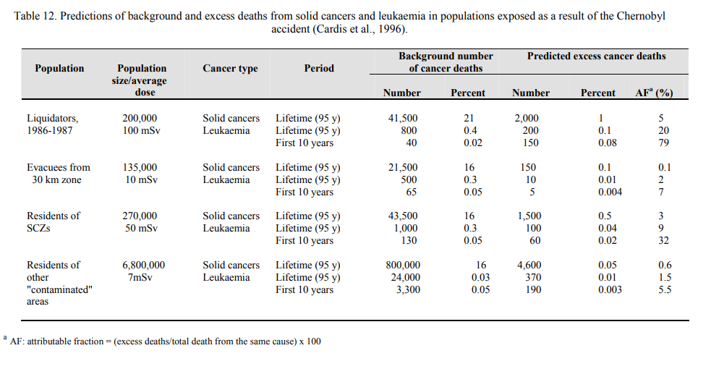

Total (in table below):  8930

Liquidators:  2200

SCZ = strictly controlled zone

Evacuees/Residents of SCZs:  1700

Larger area:  4970

This predicts about 6,000 excess cancer deaths (in addition to the liquidators).

Conservative model – linear no threshold

So, did this prediction pan out?

From World Health Organization (I have copies to share!)

Some indication of increased leukaemia and catacts amongst liquidators. Otherwise there is no clearly demonstrated increase in the incidence of solid cancers or leukaemia due to radiation in the exposed populations.

There are a large number of “background” cancer deaths. Only a tiny percentage of these would be attributable to Chernobyl.

It is possible Art’s mom’s cancer was one of those. But, there is no way to tell if one particular tumor was caused by Chernobyl. We can only study and compare the incidence rate.

Final Answer: definitively about 100

likely (based on conservative model): a few thousand

~4000 deaths (in surrounding countries)

If include all of Europe:  9000-16000

Why so much uncertainty?

Cancer is common!  Radiation relatively weak carcinogen.

~4000 deaths (in surrounding countries)

About 5 million people in contaminated areas (200,000 evacuated)

Would expect ~2 million cancers in this population

Of those, about 1 million deaths (due to cancer)

Using LNT, we think 4000 of those would be from Chernobyl

(or 0.4%)

Very hard to distinguish which of the 1 million deaths are due to Chernobyl versus other causes

**United Nations Scientific Committee on the Effects of Atomic Radiation:  100 documented deaths attributable to radiation induced cancer**

So, all that to say, definitively a few hundred deaths from Chernobyl.

Using conservative statistical probabilities:  4000-16000

Total (in table below):  8930

Liquidators:  2200

SCZ = strictly controlled zone

Evacuees/Residents of SCZs:  1700

Larger area:  4970

Realizing, definite cases of thyroid cancer (4000).

Long story short:  for most people, Chernobyl was much less of a risk factor in getting cancer than participating in certain activities (such as smoking or excessive drinking)

***Mental health

On Sun, Jul 21, 2019 at 10:55 PM Amanda Lang <[amandaleelang@gmail.com](mailto:amandaleelang@gmail.com)> wrote:

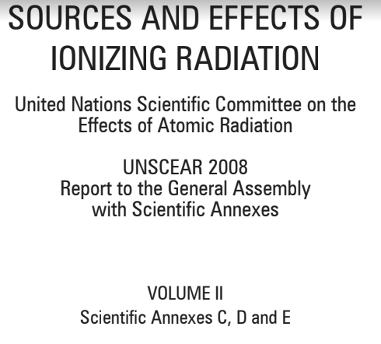

On Sun, Jul 21, 2019 at 9:20 PM Amanda Lang <[amandaleelang@gmail.com](mailto:amandaleelang@gmail.com)> wrote:

<https://www.unscear.org/docs/reports/1988annexgappx.pdf>

On Sun, Jul 21, 2019 at 7:54 PM Amanda Lang <[amandaleelang@gmail.com](mailto:amandaleelang@gmail.com)> wrote:

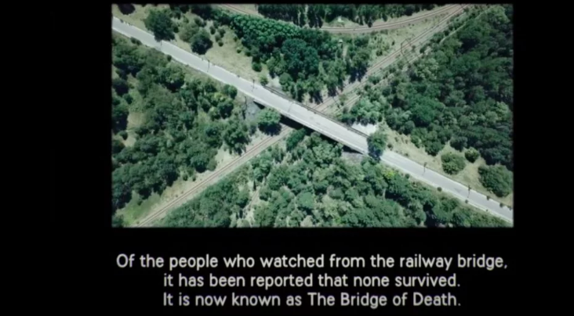

On Sun, Jul 21, 2019 at 5:18 PM Amanda Lang <[amandaleelang@gmail.com](mailto:amandaleelang@gmail.com)> wrote:

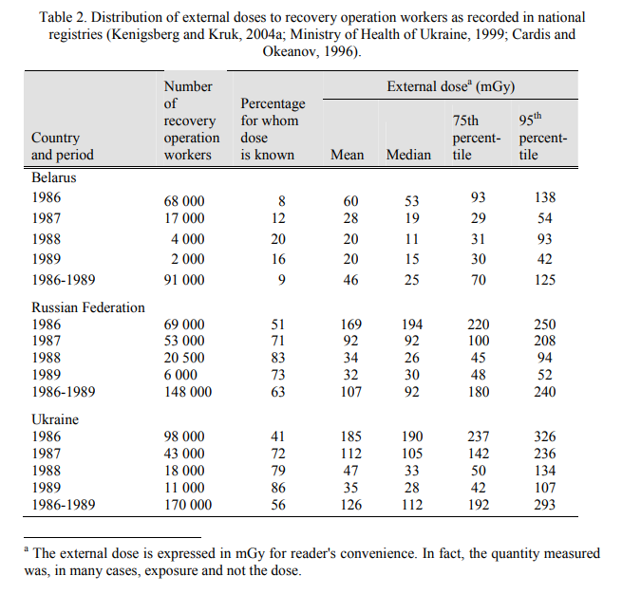

On Sat, Jul 20, 2019 at 12:34 PM Lang, Amanda Lee <[Amanda.Lang@duke-energy.com](mailto:Amanda.Lang@duke-energy.com)> wrote:

I’m radioactive, you’re radioactive.  Why?  We eat food that is radioactive (name some:  bananas, Brazil nuts, anything with potassium)

You get a “dose” from the people around you.

People are often concerned about dose they are exposed to affecting their future children and there is not evidence of that.

Radiation is considered a carcinogen meaning it can cause cancer.  When cells are quickly multiplying, a mutated cell could also quickly multiply which is why a fetus is considered more susceptible to adverse health affects from radiation.

The public often associates cell phones with radiation.  Important to point out that when we talk about dose, we are talking about **ionizing** radiation (which excludes cell phone radiofrequency waves).

Also, when we discuss how nuclear is special and unique and our responsibility to protect the health and safety of the public, nuclear accidents are discussed.

It’s important to realize that the World Health Organization has studied Chernobyl and Fukushima extensively and there weren’t many definitive adverse health affects from radiation.  However, as you can see from these excerpts (also included in your information package), there were impacts to mental health and there was trauma from the evacuation.  There is a “victim mentality” of survivors as they grapple with a much higher perceived risk than there actually was.

So, I understand that we always want to make the conservative choice and we consider ourselves so special and unique because we are nuclear, but sometimes we’re making it worse on the public.

Now, before someone gets upset, I do want to recognize that there was a statistically significant increase in childhood thyroid cancer – luckily 98% treatable.  Sadly, it’s also very preventable (but quick action was not taken by the USSR government instead they focused on a cover-up operation).

Quick tutorial:  Iodine 131 (fission product) is released as a gas when all barriers fail between nuclear fuel and the public.  It decays (8 day half-life).

If you expect to be exposed to radioactive iodine, you can take a pill (potassium iodide) to flood your thyroid with non-radioactive iodine.  The radioactive iodine will pass through your body instead of hanging out in your thyroid causing damage.

If your body already has plenty of iodine, the radioactive iodine has a much shorter biological half-life in your system and will not cause significant damage because it passes right through your body.

Why isn’t TMI up here?  Because essentially there was no release.

Similar to what was observed and reported for the Chernobyl population, the displaced Fukushima population is suffering from **psycho-social and mental health impact** following relocation, ruptured social links of people who lost homes and employment, disconnected family ties and stigmatization. A **higher occurrence of post-traumatic stress disorder** (PTSD) among the evacuees was assessed as compared to the general population of Japan. Psychological problems, such as hyperactivity, emotional symptoms, and conduct disorders have been also reported among evacuated Fukushima children. While no significant adverse outcomes were observed in the pregnancy and birth survey after the disaster, a higher prevalence of [postpartum depression](http://bmcpsychiatry.biomedcentral.com/articles/10.1186/s12888-015-0443-8) was noted among mothers in the affected region.

Several international studies have reported that exposed populations, compared to controls, had **anxiety symptom levels that were twice as high** and were more likely to report **multiple unexplained physical symptoms and subjective poor health**. …

One of the objectives of the on-going UN inter-agency International Chernobyl Research and Information Network (ICRIN) project5 (see below) is to **alleviate the stigma of psychological trauma in society, encourage self-reliance, and empower local communities to take control over their own lives**.