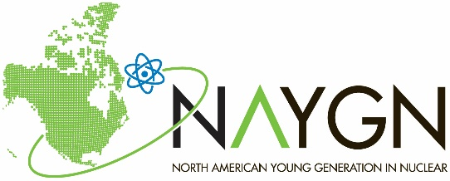
2020 Drawing Contest
2020 Fission: Bringing Nuclear Energy Into Focus

Name:_____________________________________
Grade: _____ Age: _______
T-shirt size: ________
School Name: ______________________________
City: _________________________
State/Province: ______________________
Teacher’s Name: ___________________________

How will nuclear energy help meet the energy and environmental needs of the future?
Things to consider:
Nuclear energy is carbon free
Nuclear power plants are very reliable, efficient
and have the highest capacity factors
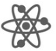
Used nuclear fuel can be recycled
New nuclear technology is extremely scalable: ability to power
small communities or giant cities in nearly any location

Draw your designs about nuclear energy on the back of this sheet!

