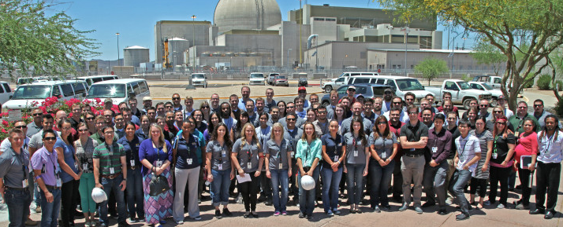  Hi there!  NAYGN depends on the financial support from our sponsors to support our vision: Developing leaders to energize the future of nuclear! Collectively, NAYGN members contribute approximately 90,000 hours a year to their nuclear organizations, local communities, and our industry, while building the skills needed to become strong and effective future leaders.  Getting Involved  To enable NAYGN to continue providing value, we are seeking corporate sponsors for 2019. If you have any questions regarding this sponsorship opportunity, please contact our NAYGN Treasurer Amber Von Ruden at treasurer@naygn.org.  NAYGN by the Numbers:  - 90,000 hours/year  - 100+ chapters  - 5,000+ members | Who We Are  NAYGN Board of Directors  - President - Amber Von Ruden  - Vice President – Monica Beistline  - Past President – Lee Causey  - Professional Development Officer – Jenny Gourley  - Public Information Officer –  Amanda Lang  - Communications Officer –  Paul Balik  - US Operating Officer – Ashley Lawrence  - Canadian Operating Officer –  Matthew Mairinger  - Treasurer – Daniel Deckman  Follow us  @NA_YGN TheNAYGN  North American young generation in nuclear  PO BOX 32642  Charlotte, NC 28242 | North American Young Generation in Nuclear (NAYGN)  Providing Support  Tiers and Benefits Available to Potential Sponsors of NAYGN
Benefits of NAYGN  - NAYGN is the largest network of young members of the nuclear industry, with over 100 chapters and thousands of members across North America.  - NAYGN offers a unique platform for developing the future leaders of the nuclear industry, focusing on soft skills, community and industry engagement, and network development.  - NAYGN offers its members Post Card Push Day resources each year to engage legislators on the benefits of nuclear.  - NAYGN also offers its members its signature Drawing Contest focused on educating Elementary School students.  - Access to NAYGN presentations, outreach kits, and even children’s books supporting nuclear energy.  - Strategic partnerships with other nuclear advocacy groups and professional societies.  - Access to peers across the North American nuclear industry. | Sponsorship Levels  