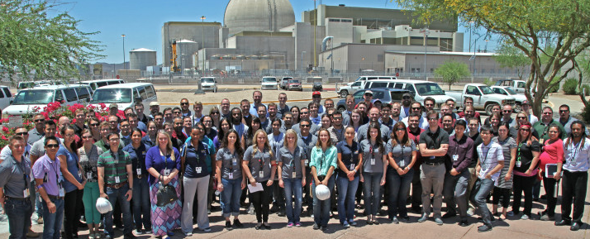  Hi there!  NAYGN depends on the financial support from our sponsors to support our vision: Developing leaders to energize the future of nuclear! Collectively, NAYGN members contribute approximately 90,000 hours a year to their nuclear organizations, local communities, and our industry, while building the skills needed to become strong and effective future leaders.  Getting Involved  To enable NAYGN to continue providing value, we are seeking corporate sponsors for 2022. If you have any questions regarding this sponsorship opportunity, please contact our NAYGN Treasurer Daniel Deckman at treasurer@naygn.org.  NAYGN by the Numbers:  - 90,000 hours/year  - 100+ chapters  - 5,000+ members | Who We Are  NAYGN Board of Directors  - President - Monica Beistline  - Vice President – Amanda Lang  - Past President – Amber Von Ruden  - Professional Development Officer – Jenny Gourley  - Public Information Officer –  Naif Siddiqui  - Communications Officer –  Farrah Abraham  - US Operating Officer – Ashley Lawrence  - Canadian Operating Officer –  Matthew Mairinger  - Treasurer – Daniel Deckman  - DE&I – Sarah Davis  - Technology Officer – Chris Chance  Follow us  @NA_YGN TheNAYGN | North American Young Generation in Nuclear (NAYGN)  Providing Support  Tiers and Benefits Available to Potential Sponsors of NAYGN
Benefits of NAYGN  - NAYGN is the largest network of young members of the nuclear industry, with over 100 chapters and thousands of members across North America.  - NAYGN offers a unique platform for developing the future leaders of the nuclear industry, focusing on soft skills, community and industry engagement, and network development.  - NAYGN also offers its members its signature Drawing Contest focused on educating elementary School students and Essay Contest for high school students.  - Access to NAYGN presentations, outreach kits, and even children’s books supporting nuclear energy.  - Strategic partnerships with other nuclear advocacy groups and professional societies.  - Access to peers across the North American nuclear industry. | Sponsorship Levels  