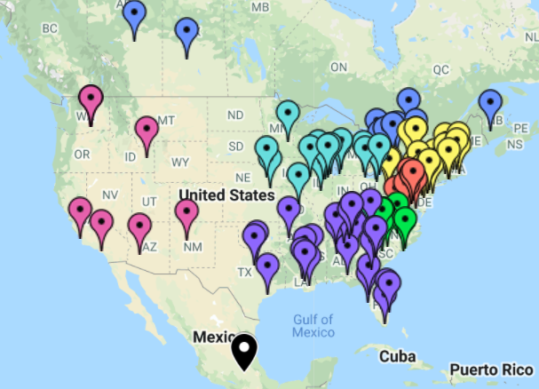Currently over 100 Chapters across the US, Canada, and Mexico.  What is NAYGN  NAYGN is a non-profit organization which provides opportunities for a young generation of nuclear enthusiasts to develop strong leadership and professional skills, create life-long connections, engage and inform the public, and inspire today’s nuclear technology professionals to meet the challenges of the 21st century. NAYGN was established in 1999 and now consists of 100+ chapters across North America. The four cornerstones are: professional development, public relations, community outreach and membership/networking.  Benefits of NAYGN  - Inform and educate the general population about nuclear science and technology;  - Provide a forum for the professional development of its membership. | Who We Are  NAYGN Board of Directors  - President - Monica Block  - Vice President – Amanda Lang  - Past President – Amber Von Ruden  - Professional Development Officer – Jenny Gourley  - Public Information Officer –  Naif Siddiqui  - Communications Officer –  Farrah Khanpour  - US Operating Officer – Ashley Lawrence  - Canadian Operating Officer –  Matthew Mairinger  - Treasurer – Daniel Deckman  - DE&I – Sarah Davis  - Technology Officer – Chris Chance  Follow us  @NA_YGN TheNAYGN | North American Young Generation in Nuclear (NAYGN)  Who we are & why you should care
Getting Involved at the Committee Level  If you are looking to contribute on a broader scale or have aspirations to join the NAYGN core someday participating in an NAYGN Committee is a great start.  To join or find out more email:  vp@naygn.org  - Benchmarking & Engagement  Canada@naygn.org & USA@naygn.org  - Regional Leads  PD@naygn.org  - PD Conference  - Webinar & virtual PD  Treasurer@naygn.org  - Sponsorship  Communications@naygn.org  - Social Media  - Awards  - Publications  PI@naygn.org  - Education, Literacy  - Government Relations  - Student education  diversity@naygn.org  - DE&I  technology@naygn.org  - Website | Getting Involved at the Chapter Level  Sign up as a member (for free!) at www.naygn.org/register to receive updates from the NAYGN organization. Also follow us on social media (@NA_YGN for Twitter/Insta/TikTok and ‘TheNAYGN’ for FB).  With so many chapters out there already there’s a good chance you have an NAYGN chapter near you! Visit https://naygn.org/chapters/chapter-list/ to see a list of the chapters across North America as well as who is the chapter contact and who is the lead for that region. Reach out to the chapter lead to request to be added to their distribution list and let them know if you are looking for a leadership role!  If there are no chapters near you and you are interested in starting up a chapter check out https://naygn.org/start-a-chapter/ and email vp@naygn.org | Examples of NAYGN Events and Activities  Professional Development  - Annual conference  - Regional NAYGN conferences  - NAYGN webinars  - Lunch & Learns  - Facility Tours and seminars  Public Information  - Post Card Push Day  - Nuclear Hill days (Ottawa, Toronto, Washington D.C.)  - School visits & teacher workshops (with NAYGN children’s book)  - Student essay/drawing contest  Community Outreach  - Charity fundraisers  - Tree planting  - Adopt a road program  - Habitat for Humanity build days  Networking & Membership  - Teamwork events  - Sporting events  - General members meetings

