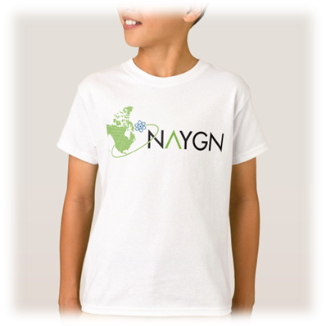[

**Submission Deadline:**Submit to [schooloutreach@naygn.org](mailto:schooloutreach@naygn.org)   
by March 31, 2023

Please contact [pi@naygn.org](mailto:pi@naygn.org) or [schooloutreach@naygn.org](mailto:schooloutreach@naygn.org) for more information.

What would you [nuclear] power?

2023 Drawing Contest

* Name
* School
* City
* State/Province
* Grade
* T-Shirt Size
* Teacher’s Name

**Format:**8½” x 11” PDF or Scan in PDF format. On the back of each drawing please include:

**Prizes:**  
1st place - Tablet, NAYGN T-Shirt, Honorary NAYGN Membership, Award Certificate, Pizza Party for the Student’s Classroom (~35 students)

2nd and 3rd place – Educational Science Kit, NAYGN T-Shirt, Honorary NAYGN Membership, Award Certificate

Each Winner’s School Library – A collection of books and materials about nuclear science and nuclear technology. The names of the winning student included on the inside cover to honor their achievement.

**Who:**Students and Grades 4 to 6 are eligible to participate

**Theme:**“What would you [nuclear] power?” emphasizing the large amounts of clean energy a single nuclear power plant can supply.